An Integrated Class Record Management System for the CCA Portal: Streamlining Academic Data and Performance Tracking

A Thesis Presented to the Faculty of
Institute of Computing Studies and Library Information Science
City College of Angeles
Angeles City



In Partial Fulfillment of the Requirement for the Degree
Bachelor of Science in Computer Science

By:
Acopio. Ross Jhem P.
Cacatian. Kurt Russel
Dela Cruz. John Edson M.
Zapanta, Ricci Neil G.

April 2025

APPROVAL SHEET
This Thesis entitled “An Integrated Class Record Management System for the CCA Portal: Streamlining Academic Data and Performance Tracking” prepared and submitted by:

Acopio. Ross Jhem P.
Cacatian. Kurt Russel
Dela Cruz. John Edson M.
Zapanta, Ricci Neil G.

In partial fulfillment of the requirements for the degree Bachelor of Science in Computer Science, has been examined and is recommended for acceptance and approval for Oral Examination.

Ms. Jannette G. Zapata |  | Mr. Angelo James Edouard M. Cruz
Thesis Instructor |  | Adviser

THESIS COMMITTEE
After having been presented is hereby accepted by the Committee on Oral Examination towards the fulfillment of the requirements for the Degree of Bachelor of Science in Computer Science.

Insert Name Here
Chairman
Insert Name Here |  | Insert Name Here
Member |  | Member

Noted by:

Mr. Aaron L. Batac |  | Ms. Maika V. Garbes
Program Coordinator, BSCS |  | Dean, ICSLIS

TABLE OF CONTENTS
APPROVAL SHEET ii
ACKNOWLEDGEMENT iii
TABLE OF CONTENTS iv
LIST OF TABLES vi
LIST OF FIGURES vii
ABSTRACT 1
INTRODUCTION 2
Background of the Study 2
Statement of the Problem 3
Objectives of the Study 3
Scope of the Study 4
Delimitations of the Study 4
Conceptual Framework / Theoretical Framework / Paradigm of the Study 5
Significance of the Study 5
Definition of Terms 6
Ethical Considerations......................................................................................................6
REVIEW OF RELATED LITERATURE AND STUDIES
METHODOLOGY 7
Algorithm 7
Research Design 7
System Development Methodology 7

Participants 8
Procedure 8
Data Analysis 8
Design and Implementation 9
Requirement Specification Analysis 9
System Design and Specifications 9
Logical Specifications 9
Hardware Specifications 10
Software Specifications 10
RESULTS 11
System / Application Outputs 11
Evaluation Results 11
DISCUSSION 12
Summary of Findings 12
Conclusions 12
Recommendations 12
REFERENCES 13
APPENDICES 14
Appendix A: Caption 14

INTRODUCTION

Background of the Study
Right now, the well-managed academic records offer really improved and definitely open doors to program-for-institution activities. Indeed, the move from paper-based methods to digital alternative has now made possible the accurate, timely, and safe handling of information. Class record management system becomes part of advanced higher education that provides teachers with proper infrastructure for systematic performance and associated administrative processes. Such popularity of systems is to be across the higher education institution as it improves data management and access to the academic record in real time (Smith and Johnson, 2023). Many earlier authors have handled academic data management. Brown and Patel (2021) construe that the appropriate strategic adoption of data management practices tends to increase efficiency in an institution, thereby increasing students' learning outcomes. This is achieved in today's digital age, where the institution holds orderly records, reduces levels of error, enhances better decision-making with respect to student follow-up, and avatars development of the curriculum.
Performance tracking has therefore become the subject of Harris and Roberts' (2022) broad, K-12 learning-oriented study in both technological and pedagogical respects. The study suggested that such technology in academic tracking affords personal learning experiences and data extraction and analysis for decision-making. Thus, there is a great need to have sophisticated systems of class record management within an educational establishment where vacancies in learning are detected early and timely interventions are brought in. To facilitate timely tracking of academic performance, Nguyen and Tran (2021) have upgraded student information systems. Their argument went on to state that the integration of artificial intelligence and predictive analytics into class records management systems will transform the manner in which educational institutions monitor student progress. These insights will subsequently enable institutions in giving proactive support to students before their dropping out rather than after and hence attain their operational achievement objectives. Henceforth, a tranquility matting system for academic records is spreading fast in all major higher institutions of education. Lee and Chan (2022) discuss the prospects and challenges of online academic portals. Improvements in access and security come at major infrastructural investments and training of academic staff towards implementation. In monetary terms, this will be a pittance compared to all the hundreds of millions of dollars in benefits that will be bequeathed to many years of timely data retrieval, immense student engagement, and so on.
The integration of learning management systems with student performance tracking has been rampantly growing. According to Williams and Foster (2021), optimizing learning achievements involves instituting learning management systems with Class record management systems, thus giving the teachers a macro view of student activity and interaction. Such institutions could benefit immensely from learning management systems/Class record management system integrations tailored to provide personalized and better learning while easing the whole administrative process. Morris and Chang (2023) presented a systematic review of educational technologies for monitoring students' performance in relation to their studies. The researchers carried out additional emphasis on using electronic means for smooth tracking and management of academic records. Hence, as technology advances, institutions should continually be updating their Class record management system so that it reflects in the current learning environment. Crude as it is, the impetus to establish integrated Class record management systems remains most pertinent on the City College of Angeles Portal, given that it deals with the academic data management with performance tracking in the measuring of the above-mentioned activities within the institutional framework. Integrated Class record management systems will serve teachers with the empowerment of data-based insight for personalized or differentiated instruction and enhanced student engagement. This conforms to the general trend in educational technology that institutions appear to be moving toward digitizing learning experiences for greater efficiencies within the institutes.
For data accuracy and integrity, digital class record management systems minimize the risk to any record keeping systems by human errors. On the other hand, digital class record management systems boost the institutions' performance in terms of compliance with educational regulations, reporting, and electronic faculty collaboration. Nonetheless, the class recording management system merits serious consideration for planning, infrastructure, and training of the faculty. These should be proactively handled to minimize resistance in implementation in order to maximize improvement on track record as such systems can provide. Basically, the provision of an integrated Class Record Management System is a milestone toward the advancement of A applications in data management and performance tracking. The studies reviewed have demonstrated how digital solutions can impact education in different dimensions; hence another justification why more advanced systems for Managing Class Records should be adopted for the enhancement of institutional efficacy and student achievement. Thus, different educational institutions all over will likely embrace much of the newly gained technological advancements; hence the reason why class record management systems shall in fact be seen as one of the major transformational change drivers for academic record management.

Statement of the Problem
Currently, the entire system of class record management is filled with increased attendance and academic performance challenges among an institution, thereby making an unsuccessful attempt for tracking academic performance as well as communication. As if this is not enough, the academic performance manual handling and inputting of data results in problems to both academic and administrative personnel because of the resulting inefficiency. Further details include these:
- Current class record managing system often needs manual input for class schedules and student enlistment details; hence making academic information more delayed and increasing chances of probably wrong entries.
- The present system does not have an automated absent tracking system; there also has been no arrangement enabling students to submit excused absences, which could be approved by instructors in a transparent way.
- The existing system does not provide an opportunity for comprehending the entire semester grades and academic performance of a student.
- The present system is less equipped in terms of communication tools available for faculty, students, and administrators.
- The last programming method only focuses on statistical analysis concerning academic performance data, thereby leaving less room for visualizing or comprehending emerging patterns and trends.

Objectives of the Study
The students will work in an integrated Class Record Management System within the CCA Portal while using the Class Record Management System to understand its need and create an effective model, and the following are the specific objectives: To focus on an integrated class record management system by CCA Portal intended at facilitating academic data management and performance tracking The study would take into consideration the development of the whole system automation for critical administrative and academic functions to efficiency and accuracy:
- To Develop an Automated System for Importing Class Schedules and Student Data.
- To Improve Attendance and Absence Management.
- To Enhance Grade and Performance Tracking Capabilities.
- To Streamline Communication and Reporting Features.
- To Incorporate Data Visualization and Ensure Cross-Platform Access

Scope of the Study
The system, then, is applicable for the faculty members and students, the registrar, the academic administrators such as program coordinators and deans. This study will consider the design, implementation, and evaluation of the Class Record Management System to cater for the expectations of all stakeholders who are involved in the management of class record, attendance, performance and communication. This system will ingest class schedules and registered students' data into the CCA Portal, providing accurate and current information. The system guarantees detailed recording for each class in a given semester and, for the previous semesters, outlines of class records which include class schedules, student attendance, raw scores and final grades. An account of student absence will also be maintained by the system for faculty approval or disapproval on excuses request and giving feedback as required after information on absence or activity missed. Henceforth, it would allow students to attach excuse note letters, which would have a view by the program coordinator and dean as well for transparency and accountability purposes.
Class schedules and enrolled student data would directly integrate with the CCA Portal so that there would be an accurate and real-time keeping track of the creation of total class records for each course in the semester and others in prior semesters. The rationale is that class records will employ class schedules, student attendance, raw scores, and totals from the final grade. Student absence records will also be maintained, whereby faculty could approve or deny excuses and leave necessary feedback regarding absences and all other missed activities. The other function would allow students to upload excuse letters for visibility; that is, these might be accessed by college authorities, program coordinators, and deans. Another key function would computerize both entry and calculation of grades. Faculty will be able to manually enter raw scores or import them, each entry being time-stamped automatically. Any modifications to scores made by the system will then be tracked in respect to a history log for accountability purposes. The actual computation of grades would be automated as per the grading system followed by CCA, along with summaries that would help ascertain the students' status with respect to pass/fail officially dropped UW, LOA, and OD status. This really speaks to minimizing errors from manual calculations and administering students' marks effectively. While the described system provides such functionalities, it also offers tools for fostering communication with faculty, students, and academic administrators. Students will receive notifications ensuring that teachers send messages concerning absentism, grades, and missed activities. The faculty will use the system to communicate with requests to program coordinators and deans for an excused absence or an enrollment change. This system will integrate various other institutional systems so that midterm and final grades are easily retrievable without manual updating. This will also provide access to current grades from mobile phones, in that manner allowing stakeholders to enter and update student data while on the go. The study would focus on data visualization as well.
Lessons learned from the research presentation revolve around creating an integrated class record management system for the academic performance optimization and tracking, as the discussions brought out conspicuously the importance of the shift in educational environments through the digital medium. According to needs, advanced class record management systems are deemed very pertinent; their use is expected to enhance the efficient functioning of educational institutions and drive student success. The modernized institutions of learning thus continue to adopt advanced technological innovations. The Class record management system would therefore provide a broad input into the topology of academic records management of things to come.
Delimitations of the Study
This study is limited to the design and implementation of an integrated class record management system for the CCA Portal, focusing specifically on academic data related to class records, attendance, grades, and student performance tracking. While the system will allow for some integration with other institutional systems, the scope of integration will be limited to academic and performance-related data, and will not extend to administrative functions outside of the academic domain, such as financial records or student health data.
The study will primarily focus on the academic needs of faculty, students, and academic administrators (registrars, program coordinators, and deans) within CCA institutions. The system will not be designed for use in non-CCA institutions or for non-academic purposes. Furthermore, the system will not directly address issues related to student registration processes or student support services, although it will provide some communication tools for coordination with academic administrators regarding student absences and performance concerns.
The system's features related to student performance tracking will be tailored to align with the grading policies and practices of CCA, which may vary across different

academic disciplines and departments. As such, the system's grading and reporting features will be designed to accommodate different grading systems, but the study will not cover the development of a standardized grading system that could be applied to all institutions.
While the system will include mobile access, it will be limited to basic functions such as viewing grades, attendance records, and class schedules. The study will not address the full scope of mobile app development or the creation of a mobile version of the portal that includes all the features available on the desktop version.
While the study will include data visualization tools for performance analysis, the scope of this feature will be limited to visual representations of student performance data such as grades, attendance patterns, and performance summaries. It will not delve into more advanced forms of data analytics or predictive modeling, nor will it include the development of personalized reports based on individual student needs beyond basic academic performance tracking.
The study’s scope is focused on the design and implementation of a user-friendly class record management system for the CCA Portal that automates and streamlines academic data handling, with a primary focus on class schedules, student performance, attendance, grades, and communication among stakeholders. The delimitation of the study ensures that the system remains within the boundaries of academic management, excluding non-academic and highly specialized features

Conceptual Framework
INPUT
Researchers Requirements:
- Group Discussion
- Brainstorming
- Process Plan
Procedure and Data Gathering(Data Analysis)
- Survey(Before the software)
- Interview(Before the software)
- Evaluation(After the software)
User Requirements:
Faculty Members
- Import class schedule and enrolled students
- Create and manage class records for current and previous semesters
- Track student attendance with absence notifications
- Enter, update, and compute grades
- Generate deliberation reports
- Identify top-performing students per term
Registrar
- Manage master list of enrolled students
- Update student enrollment status (UW, LOA, OD, etc.)
- Generate summary reports
Dean/Program Coordinator
- Approve student excuse letters
- View list of officially dropped students
- Access deliberation summaries
Students
- View attendance and absence status
- Upload excuse letters for approval
- Access grades for transparency
System Requirements:
- Data import and integration with CCA Portal
- Attendance tracking with FA status monitoring
- Score entry with manual and import options
- Grade computation and history logging
- Communication features for student engagement
- Seat plan arrangement (manual and automatic)
- Midterm and final grades fetching from class records
- Compliance with CCA grading systems
- Data visualization and performance tracking
- Search and filter functions
- Mobile accessibility
- Report generation conforming to institutional templates

An Integrated Class Record Management System for the CCA Portal: Streamlining Academic Data and Performance Tracking

PROCESS

Data Gathering

Initial Planning Phase

- Conduct Group Discussions among researchers to define objectives, scope, and key features of the system.
- Perform Brainstorming Sessions to generate ideas, identify potential challenges, and propose solutions.
- Develop a Process Plan to outline research methodology, timeline, and expected deliverables.

Pre-Implementation Data Gathering
- Conduct a Survey among faculty, students, and administrators to understand current challenges in class record management.
- Hold Interviews with key stakeholders (faculty, registrar, dean, students) to gather qualitative insights and specific requirements.
Data Processing & Management
- Import and organize class schedules and enrolled students
- Create class records for faculty accounts
- Automate attendance tracking with notifications
- Enable excuse letter submission and approval workflow
- Facilitate raw score entry and grade computation
- Generate real-time academic performance reports
Workflow Automation
- Registrar updates student status, reflected in all class records
- Dean and program coordinators approve excused absences
- Automatic fetching of midterm and final grades from records
- Communication features for missing activities and incentives
Agile Development Methodology
- Plan: Define requirements and design system architecture
- Design: Create user interface and database structures
- Develop: Implement core functionalities and integrations
- Test: Validate features with faculty, students, and administrators
- Deploy: Launch system within the CCA Portal
Review: Gather feedback and make iterative improvements

On the process in the conceptual framework, The Integrated Class Record Management System for the CCA Portal is designed to streamline academic data management and performance tracking by automating key processes for faculty, students, and administrators. The input phase involves gathering requirements through group discussions, brainstorming, surveys, and interviews to identify challenges in managing class records, attendance, and grading. The process includes developing a system that automates data import, attendance tracking, grade computation, and communication, ensuring seamless integration with the CCA Portal. Workflow automation allows real-time updates on student performance, faculty interventions, and registrar approvals for enrollment status changes. Finally, the output delivers a transparent, efficient, and accessible system where faculty can manage records with ease, students can track their academic progress in real-time, and administrators can generate standardized reports, ultimately enhancing institutional efficiency and compliance with CCA grading policies.
Significance of the Study

- To the Administrator, this study offers a significant advancement in streamlining administrative tasks related to academic data management.
- To the School, this study is valuable as it supports the institution’s goals of enhancing operational efficiency, improving student outcomes, and ensuring transparency
- To the Teachers, the study offers a tool that simplifies the process of managing class records, tracking attendance, entering raw scores, and computing grades.
- To the Students, this study is significant as it offers a transparent and efficient

platform to track their academic progress in real-time. Through the integrated class record management system, students will have easy access to their attendance, grades, and overall performance.
- To the Researcher, this study serves as a foundation for exploring the integration of technology in academic data management.
- To the Future Researcher, this study provides a model for future investigations into the impact of integrated systems in educational settings.

Definition of Terms
Import Class Schedule and Enrolled Students in CCA Portal: This feature allows for the automatic importing of class schedules and enrolled students into the system, ensuring accurate and up-to-date information.
Creation of Class Records: Facilitates the generation of class records for all courses in a faculty's account, including details of the current and previous semesters, streamlining record-keeping.
Class Records Include:
- Schedule of Class: Displays the class timetable for easy reference.
- Attendance Sheet: Tracks student absences, notifies students when they're approaching FA status, and allows for excuse submission and approval by faculty, coordinators, and deans.

- Raw Score Entry: Allows manual or imported score entries, with automatic date logging, a score history log, grade computation, and a summary of student statuses (e.g., passed, failed, LOA).
- Deliberation Form: Consolidates all student performance issues and intervention actions into one report.
- Top 10 Students per Term: Highlights the top-performing students based on their grades.
Registrar Features: Enables the registrar to manage student enrollment status, update records, and provide summary reports while deactivating students who change status (e.g., UW, LOA).
Dean/Program Coordinator Features: Allows the dean or coordinator to view dropped students, approve excused absences, and access deliberation reports related to students' performance.
Communication Features: Provides communication tools to notify students about excused absences, missing activities, and incentives, ensuring effective interaction between faculty and students.
Seat Plan: Allows the creation of a seat plan for classrooms, either manually or automatically, based on student names (alphabetically or shuffled).
Grade Visibility: Ensures transparency by making students' grades visible in their accounts, allowing them to track their academic progress.

Midterm and Final Grades Fetching: This means that midterm and end-term marks will be fetched automatically from the records without any manual entry in the system.
Grading System: It is flexible enough to cater for different grading timelines with academic structures since it can be suited to the different grading systems for courses at various institutes.
Data Visualization: The application installed at the instance of the users is for making the data analysis of the academic information with deeper meaning and enrichment.
Search and Filter Functions: Besides maximizing the user-friendliness-it refers to maximization of records search against diverse criteria with great ease.
Mobile Access: Well, the system gives possible access through mobile devices, thus opening an avenue through which faculties, students and administrators then manage academic data anytime from anywhere.
Integration with Other Systems: This into integrating with any such other academic or administrative system making that data flowing seamlessly reducing unnecessary redundancy.
Template Compliance Reports: All Reports generated will be template-compliant to the standardized templates instituted by the institution thus ensuring uniformity.
Updates Related to Recommendation: This allows a faculty or administrator to modify or update recommendations up until before an oral defense stage for flexible evaluation.

Ethical Considerations
Ethical concerns are an integral part of any research involving human participants. Due to the nature of this study, a research ethics board plays a vital role in ensuring that all processes are conducted in a fair, transparent, and responsible manner. This board independently reviews proposed research activities to protect the rights, welfare, and safety of all participants, making sure that the study aligns with established ethical standards and does not expose individuals to unnecessary risk.
This study strictly follows ethical protocols in handling personal information. It ensures that all data collected from participants is kept confidential and used solely for research purposes. Appropriate safeguards are in place to prevent any misuse of sensitive information. Structured tools such as evaluation questionnaires and organized surveys with faculty members are used to gather data and assess the proposed system. These tools are implemented with full respect for participant consent, privacy, and autonomy.
Furthermore, the study prioritizes research integrity by minimizing potential conflicts of interest and promoting honest, unbiased reporting of results. Any challenges related to trust, reliability, or ethical responsibility are acknowledged and addressed within the context of education and technology. As Kloub and Gupta (2024), “We acknowledge potential challenges related to issues of trust, reliability, and ethical considerations and aim to identify them in the educational context.”

REVIEW OF RELATED LITERATURE AND STUDIES
Foreign RRL
- Enhancing Student Performance Through Integrated Learning Analytics Dashboards
Abstract
This study investigates the meta-evaluation techniques applied on the holistic design and the inclusive leaning analytics dashboards implementing at higher education institutions. Which leads me to the question at hand — what is the value of graphically recording something that is still in process, keeping students really engaged and of something that is so readily aligned with their level of understanding? Interoperable data exchange between Learning Management Systems, student data management systems, and assessment tools

Synthesis
Modern education is associated with the addition of learning analytics dashboards that are believed to enhance student performance. Research shows that embedding such dashboards in the learning environment provides students with instant access to useful information now available to support their study. Thanks to these real-time insights, students can monitor their accomplishment and understand what they need to work on.
DOI: 10.5281/zenodo.7500860
Link: https://ijaeti.com/index.php/Journal/article/view/631

- API-Driven Data Integration for Educational Portals: Best Practices
Abstract

Learning analytics dashboards have become an important part of modern education, as they are believed to help boost student performance. When these tools are used in classrooms, they give students quick access to useful information that can support their learning. With real-time feedback, students can monitor how they're doing and spot which areas need more attention..
Synthesis
Nowadays, it’s almost impossible to build a modern educational portal without relying on APIs to bring everything together. When schools use these integrations effectively, it becomes much easier to handle things like student records, grading systems, and access to course materials. What really matters is making sure different systems can communicate smoothly while keeping everything secure and scalable for future growth. Some schools have already seen great results—sharing stories about how using APIs thoughtfully has improved their day-to-day operations and helped create a more connected learning experience across the board.DOI: 10.5281/zenodo.7500860
Link: https://ijaeti.com/index.php/Journal/article/view/631

- Cloud-Based Data Security for Academic Performance Tracking Systems
Abstract
This paper explores the challenges that come with storing academic performance data in cloud-based systems, especially when it comes to security and privacy. As more educational institutions shift to digital platforms, understanding the risks involved becomes increasingly important. The study looks into possible system vulnerabilities and suggests practical ways to safeguard sensitive student information. It also takes into account the legal side of things, discussing how schools can remain compliant with existing data protection laws while still making the most of cloud technology.
Synthesis
As more schools move their systems online, the security of academic data stored in the cloud is becoming a bigger concern. It’s not just about using the latest technology to protect student data. The real focus should be on spotting potential risks early on and making sure strong security measures are in place to keep that information safe. Schools also need to make sure they're in compliance with data protection regulations—it’s not just about the tools they use. Experts continue to stress how important it is to stay ahead in both security and legal compliance as digital tools become more widespread.This research takes a close look at the potential risks tied to storing student academic data in the cloud.
DOI: 10.5281/zenodo.7500860
Link: https://ijaeti.com/index.php/Journal/article/view/631

- Mobile-First Design for Student Academic Portals: User Experience
Abstract
This study explores how student academic portals perform on mobile devices. It looks at the design and usability features that help students quickly and easily access academic content on their smartphones. The research also examines how the design of these mobile portals affects students' engagement and overall satisfaction with their academic experience.
Synthesis
Designing with mobile users in mind is key to improving the experience of student academic portals. Studies show that factors like usability and design principles play a big role in making mobile access more efficient. When mobile access is better, students are more likely to engage with the platform and feel more satisfied with their academic experience.
DOI: 10.48550/arXiv.2202.02915
Link:https://www.researchgate.net/publication/358422504_Mobile_Based_Gradebook_with_Student_Outcomes_Analytics

- The Role of AI in Automated Gradebook Systems"
Abstract
This study looks into how artificial intelligence (AI) can be used to automate gradebook systems. It focuses on how AI can offer personalized feedback, identify students who may need extra help, and streamline the grading process. The paper also touches on the benefits and challenges that come with implementing AI-driven gradebook systems in schools.
Synthesis
AI is becoming increasingly important in automating gradebook systems. Studies show that AI can offer personalized feedback, help identify students who may be struggling, and make grading more efficient. However, there are still challenges when it comes to implementing these systems, as well as ethical concerns that need to be addressed.
DOI: 10.1186/s41239-022-00372-4
Link:https://educationaltechnologyjournal.springeropen.com/articles/10.1186/s41239-022-00372-4

Foreign RRS
- A Study on the Impact of Real-Time Performance Dashboards on Student Engagement
Abstract
This study looks at how real-time performance dashboards influence student engagement in online courses. The research examines data from a controlled experiment where students used an LMS equipped with a performance dashboard. The results reveal a clear connection between using the dashboard and a noticeable increase in student engagement.
Synthesis

This study takes a closer look at how artificial intelligence (AI) could be used to automate gradebooks. It explores how AI can help identify students who may be struggling, offer personalized feedback, and make grading faster and more efficient. The paper also dives into the possible benefits and challenges of using AI-powered gradebook systems in the classroom.
DOI: 10.18608/jla.2023.7935
Link: https://www.learning-analytics.info/index.php/JLA/article/view/7935

- Evaluating the Effectiveness of Integrated Attendance and Gradebook Systems
Abstract
This research looks at how integrated attendance and gradebook systems can help teachers work more efficiently and ensure data accuracy. It compares the performance of teachers who use integrated systems with those who rely on separate systems. The findings show that integrated systems reduce the administrative burden and lead to more consistent data.
Synthesis
Integrated attendance and gradebook systems make teachers' jobs easier and help keep data more accurate. Studies show that these systems cut down on administrative work and ensure more consistent data, especially when compared to using separate systems.

Link: https://nsuworks.nova.edu/gscis_etd/1026/
- Predictive Analytics for Early Intervention in At-Risk Students: A Longitudinal Study Abstract

This long-term study looks at how predictive analytics can help spot students who might be at risk early. By analyzing data from student information systems, it identifies patterns that could signal challenges in the classroom. The study also explores how effective intervention strategies are when they're based on these insights.
Synthesis
Predictive analytics can be super helpful in spotting students who might be struggling, making it easier to step in early. Research over time has really highlighted how good this method is at figuring out what's causing academic challenges and finding out which interventions actually make a difference.
DOI: 10.1186/s41239-019-0172-z
Link: https://link.springer.com/article/10.1186/s41239-019-0172-z

- The Effect of Parental Access to Online Portals on Student Academic Performance
Abstract
This study explores how having access to online portals can affect student performance. By looking at data from schools with active parent portal systems, the research shows a clear connection between parents being involved through these portals and improvements in student grades.
Synthesis
When parents have access to online portals, it can positively affect their child's academic performance. Research shows that students tend to have better grades when their parents are involved through these portals, proving that this kind of involvement really makes a difference.
DOI: 10.3102/0034654314550793
Link: https://journals.sagepub.com/doi/10.3102/0034654314550793

- Comparative Study of Cloud-Based vs. On-Premise Class Record Systems
Abstract
This study compares the benefits and drawbacks of cloud-based and on-premise class record systems. The research analyzes data from multiple school districts using both types of systems. Results show that cloud-based systems offer greater scalability and accessibility, while on-premise systems provide greater control over data security.
Synthesis
Cloud-based class record systems are more scalable and easier to access compared to on-premise systems. However, on-premise systems give schools more control over data security. Studies comparing the two highlight the trade-offs, showing both the advantages and disadvantages of each option.
DOI: 10.1016/j.procs.2019.09.123
Link: https://www.sciencedirect.com/science/article/pii/S1877050919316123
Local RRL
- Development of Student Information Systems in Philippine Universities: Challenges and Opportunities

Abstract
This paper looks at how student information systems (SIS) are being developed and used in Philippine universities, focusing on the challenges like limited infrastructure, data management issues, and getting users fully on board. It also highlights opportunities for improvement, such as making systems more user-friendly and better integrated. The study looks at how these systems can evolve in the future to better support both students and universities.
Synthesis
Student information systems in Philippine universities are evolving, but they still face big challenges like weak infrastructure and data management problems. On the bright side, there's a lot of room for improvement—like making the systems easier to use and more connected, which could really help simplify administrative tasks.
DOI: 10.5296/jpag.v14i2.22325
Link: https://www.macrothink.org/journal/index.php/jpag/article/view/22325

- Mobile Technology Integration in Classroom Management: Philippine Context
Abstract
This review looks into how mobile technology is being used for classroom management in the Philippine education system. It covers how mobile devices help with things like tracking attendance, communicating with students, and sharing learning materials. It also talks about both the benefits and the challenges of using mobile tech in different school settings.
Synthesis
This review takes a closer look at how mobile technology is being used to help manage classrooms in the Philippines. It talks about how teachers use devices like smartphones and tablets to take attendance, stay connected with students, and share learning materials more easily. It also breaks down the pros and cons of using mobile tech in different types of schools, pointing out both the challenges and the ways it can make teaching and learning smoother.
DOI: 10.51798/sijis.v2i3.114
Link: https://journals.sapienzaeditorial.com/index.php/SIJIS/article/view/114

- Data Privacy and Security in Philippine Educational Institutions: Current Practices
Abstract
This paper explores how schools and universities in the Philippines are managing data privacy and security. It looks into how closely these institutions follow data protection laws and highlights areas where improvements are needed—especially in making sure that student and staff information is properly protected.
Synthesis
Data privacy and security are major concerns for schools and universities in the Philippines. While many institutions are working to meet data protection requirements, research shows there’s still a lot of room to improve how sensitive student information is handled and kept safe.
DOI: 10.5296/jpag.v14i2.22325
Link: https://www.macrothink.org/journal/index.php/jpag/article/view/22325

- E-Learning Platforms in Philippine TVET Institutions: Implementation and Impact
Abstract
This study looks at how e-learning platforms are being used in Technical-Vocational Education and Training (TVET) institutions in the Philippines. It focuses on how effective online tools are for teaching technical skills and knowledge. The paper also talks about the challenges these schools face when using e-learning and the potential benefits it could bring to the education system.
Synthesis
- learning platforms are crucial in teaching technical skills in Philippine TVET institutions. Research looks at how well these platforms work, pointing out challenges like infrastructure issues and gaps in digital literacy. It also highlights the opportunities they offer for improving access to quality education and bridging the skills gap.
DOI: 10.5296/jpag.v14i2.22325
Link: https://www.macrothink.org/journal/index.php/jpag/article/view/22325

5. The Implementation of K-12 Learning Management Systems in the Philippine Public School System
Abstract

This paper examines how learning management systems (LMS) are being used in the Philippine K-12 public school system. It looks at how widely these platforms are being adopted, the challenges schools face in using them, and the benefits they bring to the classroom. The paper also discusses how LMS is impacting teaching and learning outcomes.
Synthesis
The adoption of LMS in Philippine K-12 public schools comes with both advantages and challenges. Research shows how these platforms are being used and their effect on teaching and learning. It also points out that improvements are needed in infrastructure and teacher training to help schools make the most out of these systems.
DOI: 10.18178/ijiet.2023.13.3.1823
Link: https://www.ijiet.org/show-186-2417-1.html
Local RRS:
- Effectiveness of Online Grade Submission Systems in Philippine Universities
Abstract
This study looks at how effective online grade submission systems are in Philippine universities. It explores how these systems affect faculty efficiency, the accuracy of data, and student satisfaction. The research also highlights areas where improvements can be made to make the grade submission process better.
Synthesis
Online grade submission systems bring several benefits to Philippine universities, such as boosting faculty efficiency and improving data accuracy. Research shows that these systems make the grading process more efficient overall, but also points out that there's room for improvement based on user feedback to make them even better.
Link:https://www.academia.edu/76906756/Online_Student_Academic_Performance_Monitoring_and_Evaluation_System_of_the_Quirino_State_University

- Impact of Real-Time Attendance Monitoring on Student Punctuality in Rural Philippine Schools
Abstract
This study looks at how tracking attendance in real-time can improve student punctuality in rural schools in the Philippines. It focuses on using mobile technology and SMS notifications to keep tabs on attendance. The research examines how this kind of monitoring may lead to better attendance rates among students.
Synthesis
Real-time attendance tracking through mobile tech and SMS can really help improve student punctuality in rural schools in the Philippines. Studies show that by keeping parents and students updated quickly, it can lead to better attendance overall.
Link:https://ojs.aaresearchindex.com/index.php/aajmrcp/article/view/12686
- Development and Evaluation of a Localized Learning Management System for Indigenous Communities
Abstract

This study looks at how a learning management system (LMS) was developed to meet the needs of indigenous communities in the Philippines. It focuses on how the system was adapted to respect cultural differences and use local languages. The research also explores how this personalized LMS impacts students' learning and outcomes.
Synthesis
Designing LMS platforms for indigenous communities requires a deep understanding of their culture and language. When done right, these platforms can make learning more effective and relevant, ensuring that the content truly speaks to the community's needs and values.
Link:https://www.academia.edu/98625341/Online_Student_Academic_Performance_Monitoring_and_Evaluation_System_of_the_Quirino_State_University

- Parental Involvement Through Online Portals: A Case Study in a Philippine Private School
Abstract
This case study looks at how parental involvement through online portals impacts a private school in the Philippines. It explores how parents use the portals to communicate, access grades, and share resources. The research also examines how parents' use of these portals relates to student academic performance.
Synthesis

Online portals are improving parental involvement in Philippine private schools. Research shows that when parents use these portals, student academic performance tends to improve, thanks to better communication and easier access to academic information.
Link:https://www.academia.edu/98625341/Online_Student_Academic_Performance_Monitoring_and_Evaluation_System_of_the_Quirino_State_University

- Analysis of Learning Analytics in a Philippine State College
Abstract
This study looks at how learning analytics is used in a state college in the Philippines. It explores how data-driven methods are implemented to track student progress and pinpoint areas where improvement is needed. The research also examines how learning analytics influences teaching and learning practices.
Synthesis
Learning analytics provides valuable insights that can help improve teaching and learning in Philippine state colleges. Research explores how data-driven approaches are being implemented and looks at their impact on student progress and overall educational outcomes.
Link: https://journals.gsu.edu.ph/higher-education-research-review/article/view/13

METHODOLOGY
An Integrated Class Record Management System for the CCA Portal: Streamlining Academic Data and Performance Tracking A Website for City College of Angeles includes different technical models, algorithms and analytics used in conducting the study. The techniques, plans and strategies used in planning, designing and development were systematically analyze and discussed.
Algorithms
Figure 2:Registrar’s View Algorithms
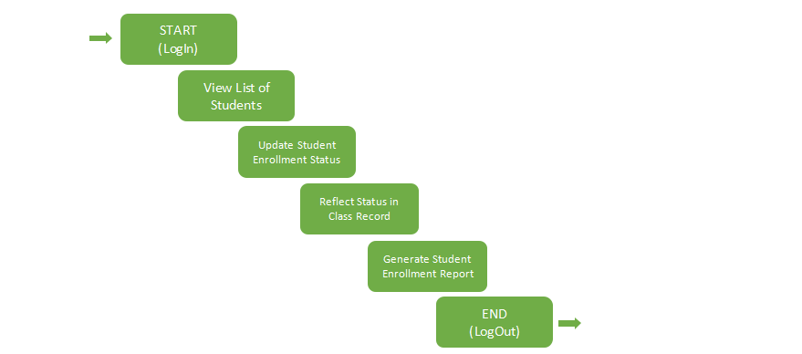
The system incorporates a CRUD (Create, Read, Update, Delete) algorithm to manage student records efficiently. The registrar can create new student entries, read or view existing student data, update details such as enrollment status or personal information, and delete records of students who are no longer part of the institution. This CRUD functionality ensures comprehensive and flexible data management within the registrar’s workflow. The Registrar starts by logging in to the system by entering their

username and password to have an access. Once logged in, the registrar can view the list of students, which includes all enrolled students from the current or previous semesters. The registrar can selects a specific student and proceeds to update their enrollment status, with options to change the status to Enrolled, UW (Unauthorized Withdrawal), LOA (Leave of Absence), or OD (Official Drop). The registrar also provides necessary remarks and sets the date for the status change. After updating the status, the registrar ensures that the student’s status is reflected in the class records, where the student's new status will be updated, and the student’s record will be deactivated if applicable (UW, LOA, or OD). This update ensures that the student’s academic record is aligned with their current enrollment status. Once the necessary status updates are made, the registrar can generate and download a report summarizing the enrollment statuses of all students (Enrolled, UW, LOA, OD). After completing all required tasks, the registrar logs out of the system to securely end the session. This algorithm ensures that the registrar can efficiently manage and track student enrollment changes while maintaining accurate class records and reporting.
Figure 3: Instructors’ View Algorithm

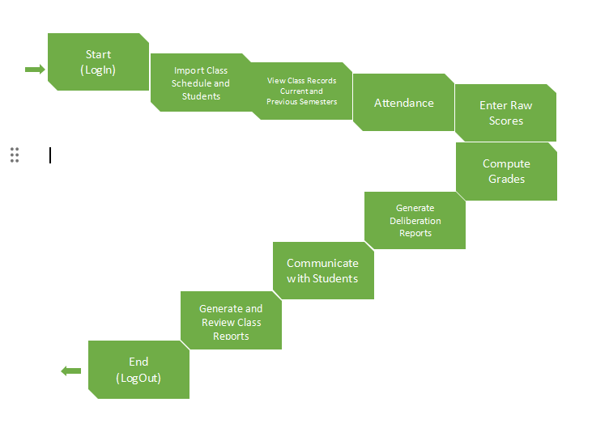
The system includes a Weighted Average Algorithm to calculate students’ final grades accurately. This algorithm assigns specific weights to different assessment components (e.g., quizzes, exams, projects, attendance) and computes the final grade based on their proportional contribution. By automating this process, the system ensures consistency, fairness, and transparency in grade computation across all subjects. The Instructor’s academic management system starts with logging into their faculty account to access teaching records and tools. After logging in, instructors can manage their class schedules and student lists for the term. They are able to view comprehensive class records, including past and current attendance, grades, and schedules. Attendance

tracking is handled through the system, which also notifies students of absences and their status. Instructors can manage excused absences by approving them or forwarding requests to higher authorities. Raw scores for various assessments are entered manually or imported, and the system calculates final grades automatically. If a student is under-performing, the instructor can generate a deliberation report with notes on interventions. The system also enables communication with students and the generation of final class reports summarizing performance and attendance.
Figure 4:Student’s View Algorithm
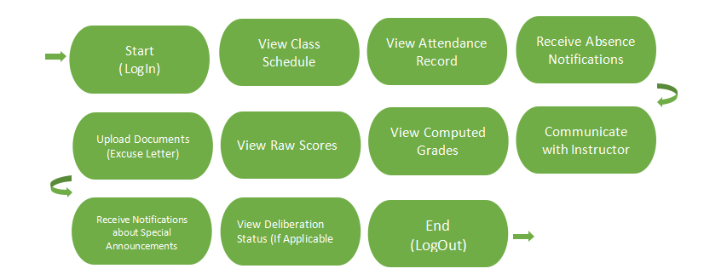
The system includes Direct Communication Algorithm to streamline interactions between students and faculty. This algorithm enables secure, real-time messaging within the portal, allowing students to directly contact instructors, coordinators, or administrators regarding academic concerns. It ensures that all communication is logged and organized, fostering efficient, transparent, and responsive dialogue within the academic environment. The Student starts with logging into their given account to access their academic dashboard. Once logged in, students can view their class schedule,

including course times and assigned instructors. They can check their attendance records for each class and receive automatic warnings if they have too many absences. If they miss a class, students can upload excuse letters and supporting documents through the system. They can also track the status of their excused absences to see if approval is needed from instructors, coordinators, or deans. The system allows students to view raw scores for quizzes, assignments, and exams as instructors update them. Once all scores are entered, students can see their final computed grades. They can send messages to instructors for clarification on grades, assignments, or feedback. The portal also sends notifications for important announcements like missing assignments, deadlines, or class updates. If a student is involved in a performance review or intervention, they can view updates on their deliberation status, keeping them informed and involved in their academic progress.
Figure 5:Dean’s View Algorithm
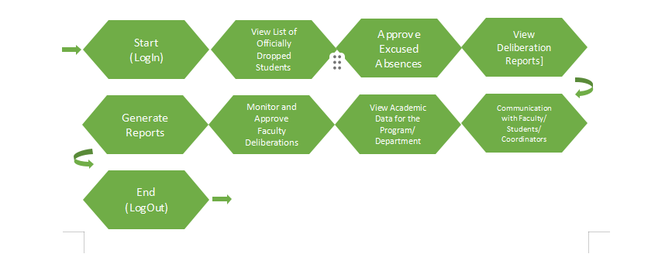

The system includes a Data Aggregation Algorithm to compile and summarize large volumes of academic and administrative data. This algorithm collects information from various sources such as grades, attendance, interventions, and enrollment and organizes it into comprehensive, easy-to-analyze formats. It enables the Dean to efficiently monitor trends, evaluate departmental performance, and make informed decisions based on real-time, consolidated data. The Dean starts by logging into their account to access the administrative dashboard. They can view a regularly updated list of students who have officially dropped courses, helping them stay informed about enrollment changes. The Dean also reviews and approves excuse letters for student absences that require higher-level validation. Deliberation reports from instructors and coordinators are accessible to the Dean, allowing them to assess academic concerns and suggested interventions. They can generate detailed reports to monitor student performance, pass/fail rates, and departmental trends. The Dean also reviews and approves faculty-submitted intervention reports to ensure consistency and fairness. Aggregated academic data at the program or department level is available to help the Dean track performance and identify areas needing improvement. Lastly, the Dean can send official messages or notices to faculty, students, and coordinators to provide guidance, reminders, or updates.

Figure 6:Admin’s View Algorithm
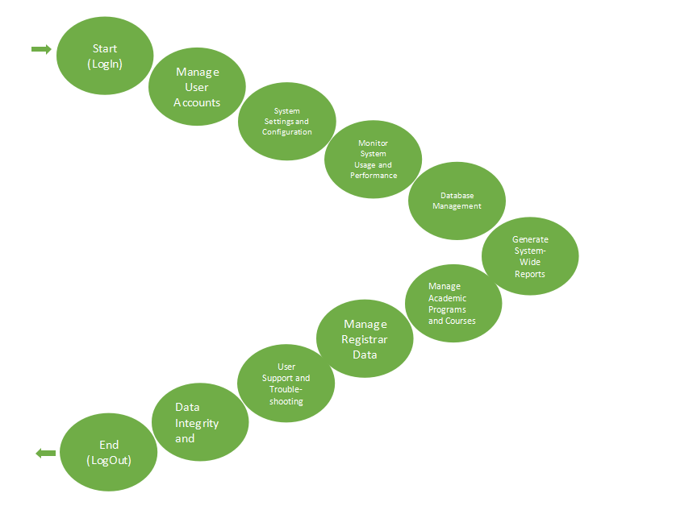
The system includes Role-Based Access Control (RBAC) Algorithm to allow admins to assign specific permissions based on user roles such as student, instructor, registrar, or dean. This algorithm ensures that users only have access to the tools and data relevant to their role, enhancing security and operational efficiency. By managing roles through RBAC, admins maintain structured control over system access, preventing unauthorized actions and protecting sensitive information. The Admin starts by logging into the CCA portal to access all the system tools. They manage user accounts by creating, updating, or deactivating accounts for students, teachers, and Deans. Admins set roles and permissions so users only see what they need. They also set up system settings

like grading rules, notifications, and report templates. Admins keep an eye on how well the system is running and fix any slowdowns or errors. They make sure data is backed up, correct mistakes, and move data when needed. The admin can create reports that show how the system is being used. They also manage academic programs and courses, updating or removing them when necessary. Admins work with the registrar to keep student records, enrollments, and course lists up to date. They help users with any problems, protect data, and check for any strange or harmful activity in the system.
CCA Portal
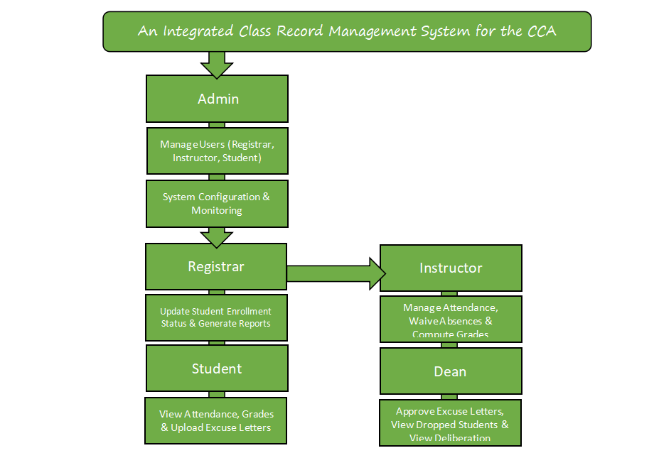

The system includes Search and Filtering Algorithm to help users quickly locate specific records or information. This algorithm allows users to search by keywords and apply filters based on criteria such as name, course, date, enrollment status, or performance metrics. By streamlining data retrieval, it enhances user efficiency and accuracy when managing or reviewing large volumes of academic records.
The system operates with distinct user roles, each having specific responsibilities to ensure efficient management of class records. The Admin manages the system's configuration, oversees user accounts (Registrar, Instructor, Student, Dean), and ensures the system runs smoothly. The Registrar is responsible for updating student enrollment statuses, reflecting these changes in class records, and generating student status reports. Instructors manage attendance, grades, and track student performance, while also being able to approve or forward absences for further review and waive absences if needed. Students can track their attendance and grades and submit excused absence requests, which are reviewed by instructors or forwarded to the Dean for final approval. The Dean reviews and approves excused absence letters, manages dropped students, and has access to deliberation reports regarding student performance.
Each user role operates within their designated tasks, with the Admin ensuring system integrity and configuration, the Registrar keeping enrollment data accurate, Instructors focusing on academic performance, Students interacting with their own records, and the Dean overseeing absences and performance interventions. This division

of responsibilities ensures a seamless flow of information, effective management, and transparent communication across all levels of the academic system.

Research Design
The Integrated Class Record Management System (ICRMS) for the CCA Portal aims to streamline academic data and performance tracking by automating grade management and improving accessibility for teachers, students, and administrators. According to Singh and Sharma (2021), the use of digital record management systems in educational institutions enhances efficiency by reducing manual errors and providing real-time access to academic data. Additionally, Garcia et al. (2023) emphasize that automated systems significantly improve data accuracy and minimize processing time, leading to better overall performance in academic institutions. With these advantages in mind, the researchers developed this study to address the challenges of manual record-keeping at City College of Angeles (CCA).
The research design used in this study is a Descriptive Research Design to identify the primary issues faced by CCA faculty and staff in managing academic records. This design aims to determine the efficiency, accuracy, and user satisfaction of the current system compared to the proposed ICRMS. By gathering data, this research will reveal common struggles teachers encounter, such as grade computation errors, time-consuming encoding processes, and data retrieval issues. Additionally, the study will

focus on how students and administrators perceive the new system in terms of accessibility, convenience, and performance.
System Development Methodology

An Integrated Class Record Management System for The CCA Portal: Streamlining Academic Data And Performance Tracking
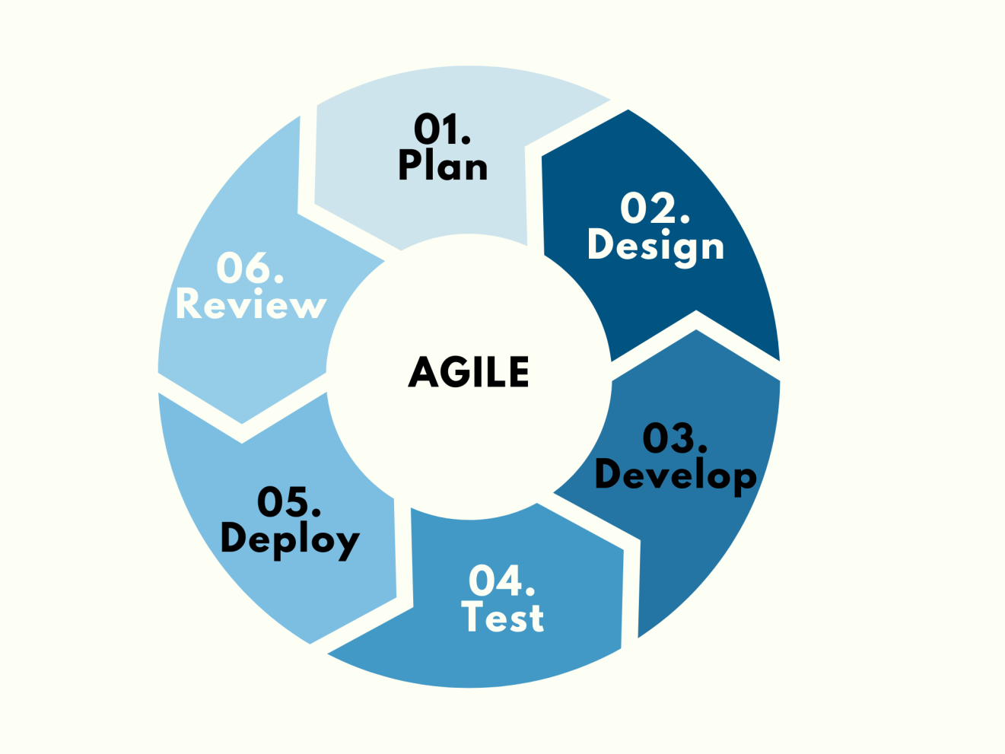
Plan - At the beginning of the study, the researchers identified the gaps and needs within the existing academic processes at the City College of Angeles. The primary goal was to develop an integrated student portal that would streamline academic performance

tracking for both students and faculty members. This system aims to provide better efficiency, ease of use, and faster access to important academic information—while also reducing the time spent on manual, in-person processes such as letter approvals. To better understand the current challenges and requirements, the researchers distributed questionnaires to school administrators and gathered detailed feedback from faculty and students.
Design - At this stage, the researchers outlined a set of key features to be included in the system, prioritizing user-friendliness and addressing the specific needs of the school. Suggestions from administrators were carefully considered to ensure the system fits well with existing processes. The design also aimed to make the system accessible to all users, even those with minimal computer skills.
Develop - The researchers utilized HTML, CSS, JavaScript, JSON, SweetAlert (Swal), CRUD operations, and a database to develop a fully web-based system titled “An Integrated Class Record Management System for the CCA Portal: Streamlining Academic Data and Performance Tracking.” The system was designed to run efficiently across various devices, with a responsive layout and remote accessibility. This ensures flexibility, allowing users to access and use the system anytime and anywhere.
Test - The testing phase plays a critical role in the system development process, as it focuses on identifying and resolving potential bugs, errors, and functional issues. Comprehensive testing will be conducted to verify that all system features operate as

expected. A selected group of users—including faculty members, students, and two information technology experts—will participate in the evaluation process. Their feedback will be analyzed by the researchers to detect and address any technical or usability concerns. This phase ensures that the system is both functional and user-friendly, effectively meeting the needs of its intended users.
Deploy - The system has been thoroughly prepared for deployment, with all essential institutional data securely integrated while upholding strict privacy and confidentiality standards. Nevertheless, a crucial prerequisite remains: the complete resolution of all identified bugs, errors, and issues uncovered during the testing phase. The transition to the deployment stage will only proceed once these concerns have been comprehensively addressed, thereby ensuring the delivery of a stable, reliable, and fully operational system for the academic community.
Review - Quality control was a key focus, with researchers carefully overseeing each development phase to ensure alignment with the project’s objectives. Thorough testing identified and resolved any bugs, ensuring the system’s reliability. For future improvements, regular post-deployment evaluations could further enhance performance and user satisfaction.
Launch - The Integrated Class Record Management System for the CCA Portal: Streamlining Academic Data and Performance Tracking is now accessible to the public. This intuitive, web-based platform is designed to simplify various processes for both staff

and students. To encourage widespread adoption among students, the administration will initiate a comprehensive marketing campaign. The research team remains dedicated to ongoing development, ensuring the system remains up-to-date and optimized.
Participants
Our participants in this study are the students, faculty or office staff, and teachers from City College of Angeles (CCA) since they are the primary users of the CCA Portal and can provide valuable feedback on its usability and effectiveness. We conducted a survey to gather their opinions and experiences with the portal, including questions about usability, efficiency, accessibility, and overall user experience. We also asked for their satisfaction level and suggestions for improvement. For the evaluation, we used a quantitative descriptive research design, which focuses on collecting numerical data to describe and analyze trends, patterns, and overall perceptions of the respondents. Since our survey consists of yes or no questions, we gathered clear and measurable responses to assess the system's effectiveness.
We used convenience sampling, where we distributed the survey through a Google Form link shared via Facebook Messenger, making it easier and faster to collect responses. According to Winton and Sabol (2021), convenience sampling is widely used in research because it is accessible, cost-effective, and easy to conduct. We agree with

this because using an online survey allowed us to quickly gather responses from our target participants. However, as their study mentions, the type of sample source can affect research results, so we carefully considered how we collected and analyzed the data to ensure meaningful findings.
Procedure
The study employs both quantitative and qualitative methods. The quantitative aspect involves conducting surveys and collecting numerical data from CCA faculty and students to measure the system’s efficiency and accuracy. The researchers will analyze the data by calculating means and percentages to assess the system's effectiveness. On the other hand, the qualitative aspect will involve interviews and open-ended questionnaires with selected respondents to gather their experiences, feedback, and suggestions. This combination of methods will help the researchers evaluate whether the ICRMS is user-friendly, efficient, and beneficial for CCA’s academic performance tracking needs.

Data Analysis
The researchers will apply the quantitative data gathered through the evaluation questionnaires with a Likert scale to examine and understand the collected information related to the "Integrated Class Record Management System for the CCA Portal". This method focuses on numbers and statistics to measure and summarize the results, ensuring that the findings are clear and reliable. The analysis will include calculating the arithmetic mean to determine the average student performance, generating a frequency

distribution to organize data such as attendance records and grading trends, and using percentage distribution to show the proportion of students in different grade categories or attendance status. These statistical methods will help identify patterns and trends in class performance, attendance tracking, and faculty-student interactions, making it easier to assess the effectiveness of the system. By applying these techniques, the study aims to provide accurate insights that will support improvements in academic data management and decision-making within the CCA Portal.
Table 1. Likert Scale
Numerical Rating | Description
5 | Excellent
4 | Very Good
3 | Good
2 | Fair
1 | Poor
This scale helps understand how well the system works in terms of usefulness, ease of use, and efficiency. The ratings will be analyzed using the arithmetic mean to determine the overall user experience.

Arithmetic Mean
The arithmetic mean (average) will be used to find the overall rating of the system based on survey answers. It is calculated using the formula:
Mean Mean = S/N
Where:
- S = Total of all ratings
- N = Number of responses
This will help summarize user feedback into one overall score, showing whether the system is effective or needs improvement.

Frequency Distribution
Frequency distribution is used to count how many times a specific response appears in the data. It helps organize information such as attendance records, student grades, and survey responses into categories. This data can be shown in tables, bar graphs, or pie charts to make it easier to see trends. The formula is:
fx​= Frequency of x
Where fx is the number of times a specific rating or response appears in the dataset.

Percentage Distribution
Percentage distribution is used to show the proportion of responses in relation to the total number of responses. It helps understand how many students fall into different grade levels or attendance categories. The formula is:
P = (F/N)×100
Where:
- P = Percentage
- F = Frequency (number of times a response appears)
- N = Total number of responses
This method helps display results in tables and charts for better understanding.

Interpretation of Evaluation Results
To make the results more understandable, a descriptive rating scale will be used to translate numerical scores into simple descriptions:
Table 2. Scale for Interpreting the Evaluation Results
Numerical Ratings | Description
4.2 - 5.00 | Excellent
3.4 - 4.19 | Very Good
2.6 - 3.39 | Good
1.8 - 2.89 | Fair
1.0 - 1.79 | Poor

This helps turn numbers into clear meanings, making it easier to understand whether the system is performing well or needs improvement. Using these quantitative methods, the study will provide accurate, data-based insights into the system’s usability and effectiveness.

Design and Implementation

Requirement Specification Analysis
The Integrated Class Record Management System (ICRMS) for the CCA Portal is designed to streamline academic data management and performance tracking. This system ensures that all academic processes—from enrollment to grading—are efficiently handled by automating key functions and enabling role-based access for different users. The portal aims to minimize administrative overhead, improve communication, and maintain the accuracy of student records.
The application features five key modules based on the user's role: Student, Instructor, Registrar, Dean, and Administrator. Each module provides specific tools to ensure that users can perform their responsibilities securely and efficiently.

Student Module - The Student Module is designed to empower learners by giving them visibility and control over their academic progress while promoting timely communication and accountability. Upon successful login, students are presented with an

intuitive dashboard where they can access key academic tools and notifications relevant to their coursework and performance.
- View Class Schedule – Students can view their current and past course schedules including instructors and room assignments.
- Attendance Record – Allows students to track their attendance status, including approved excused absences and system warnings for excessive absences.
- Upload Documents – Enables uploading of excuse letters and supporting files when classes are missed.
- View Grades – Shows both raw scores and computed final grades once instructors finish encoding them.
- Deliberation Status – Students under academic performance monitoring can track their deliberation process and outcomes.
- Communication – Real-time messaging system allows secure communication with instructors, coordinators, or deans.
- Notifications – Sends alerts about important updates such as missed classes, new grades, or administrative announcements.

Instructor Module - The Instructor Module is developed to facilitate the seamless management of academic tasks, from tracking student attendance to computing final grades. This module enhances instructional efficiency while ensuring the accuracy and transparency of academic records.
Instructors have the following functionalities available in their portal:

- Manage Class Records – View and update attendance, class schedules, and student performance for current and past semesters.
- Enter Raw Scores – Encode assessment results such as quizzes, exams, and projects.
- Compute Grades – Automatically calculates final grades using a Weighted Average Algorithm for consistency.
- Generate Reports – Class performance reports and deliberation summaries can be generated for academic review.
- Attendance Management – Instructors can mark absences, approve excuse letters, or escalate them to coordinators or deans.
- Communication – Direct messaging with students to provide feedback or answer academic concerns.

Registrar Module - The Admin Module functions as the central control hub of the entire system. Administrators are responsible for managing user access, configuring system settings, and ensuring the smooth operation, security, and integrity of the portal. This module supports all other user roles by providing technical maintenance and structural management tools.
The registrar handles enrollment and student status through these features:
- View Student List – Access to enrolled students by semester.

- Update Enrollment Status – Can change a student’s status to Enrolled, UW (Unauthorized Withdrawal), LOA (Leave of Absence), or OD (Official Drop).
- Class Record Syncing – Changes in status are automatically reflected in the student's academic record.
- Generate Enrollment Reports – Summary reports on student statuses can be exported for institutional use.
The system uses a CRUD algorithm for managing student records—allowing creation, reading, updating, and deletion of entries as needed.

Dean Module - The Dean Module is designed to provide high-level academic oversight and decision-making tools. It allows deans to monitor department-wide performance, handle escalated student concerns, and ensure consistent academic standards across programs. Through data aggregation and reporting features, this module supports informed strategic planning and academic governance.
The Dean’s dashboard is equipped with data analytics tools and oversight features:
- Approve Excused Absences – Final authority to validate high-level excused absences.
- View Dropped Students – Access the list of officially dropped students and reasons.
- View Deliberation Reports – Monitor students under review and approve instructor interventions.

- Generate Reports – Department-wide reports for academic trends, performance, and retention.
- Communication Tools – Send announcements and instructions to faculty and students.
The Dean’s module utilizes a Data Aggregation Algorithm to process and present summarized academic data.

Administrator Module - The Admin Module functions as the central control hub of the entire system. Administrators are responsible for managing user access, configuring system settings, and ensuring the smooth operation, security, and integrity of the portal. This module supports all other user roles by providing technical maintenance and structural management tools.
Admins maintain and secure the system:
- Manage Users – Control over creation, editing, and deactivation of accounts for students, instructors, registrars, and deans.
- System Configuration – Modify system rules, grading criteria, notification settings, and more.
- Monitor System Performance – Tracks performance, uptime, and potential issues.
- Database Management – Handles backups, data transfers, and integrity checks.

- Role-Based Access Control (RBAC) – Assigns system access based on user roles for data security.
- Generate System Reports – Insights into user activity, system usage, and administrative changes.
- Academic Program Management – Adds or removes courses and assigns them to departments or users.

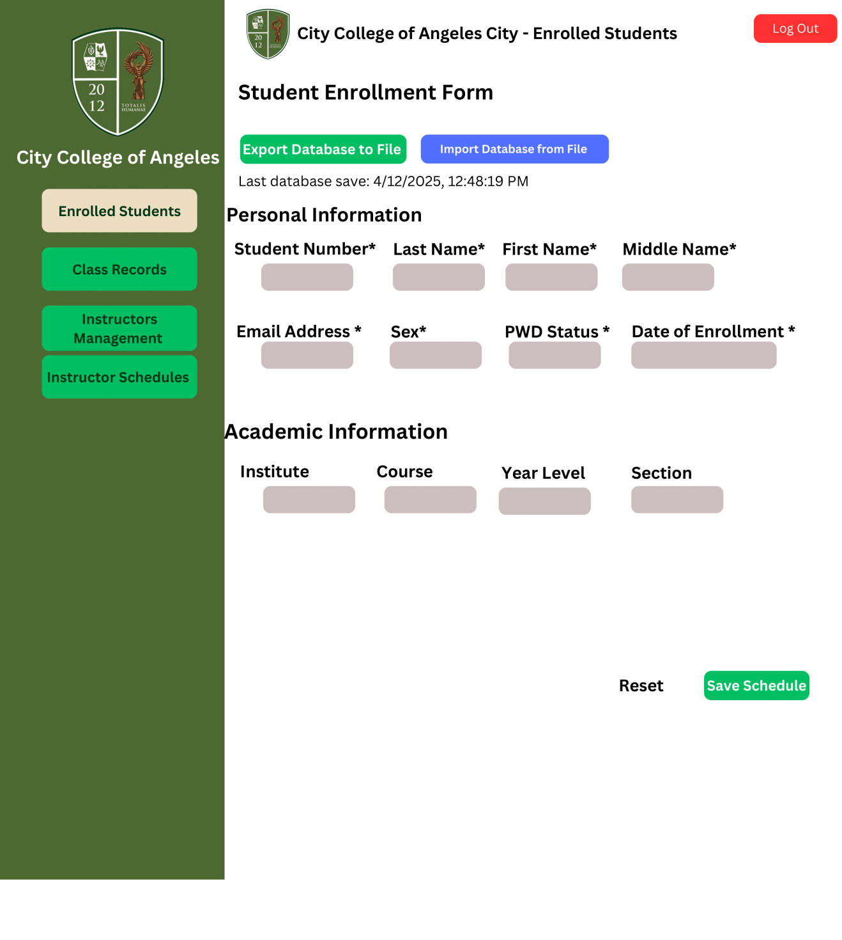
System Design and Specifications

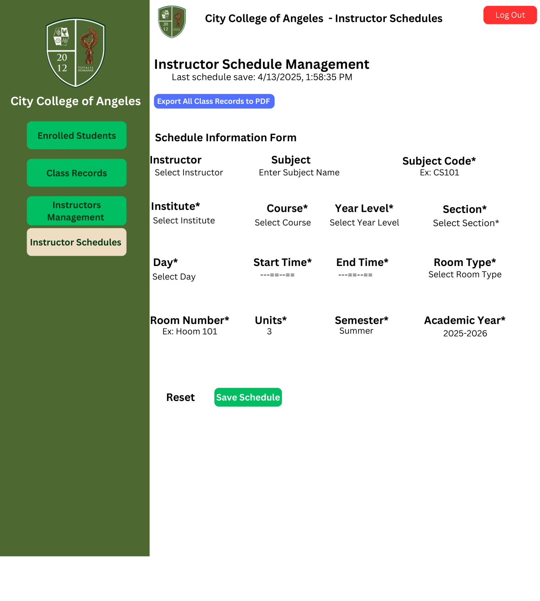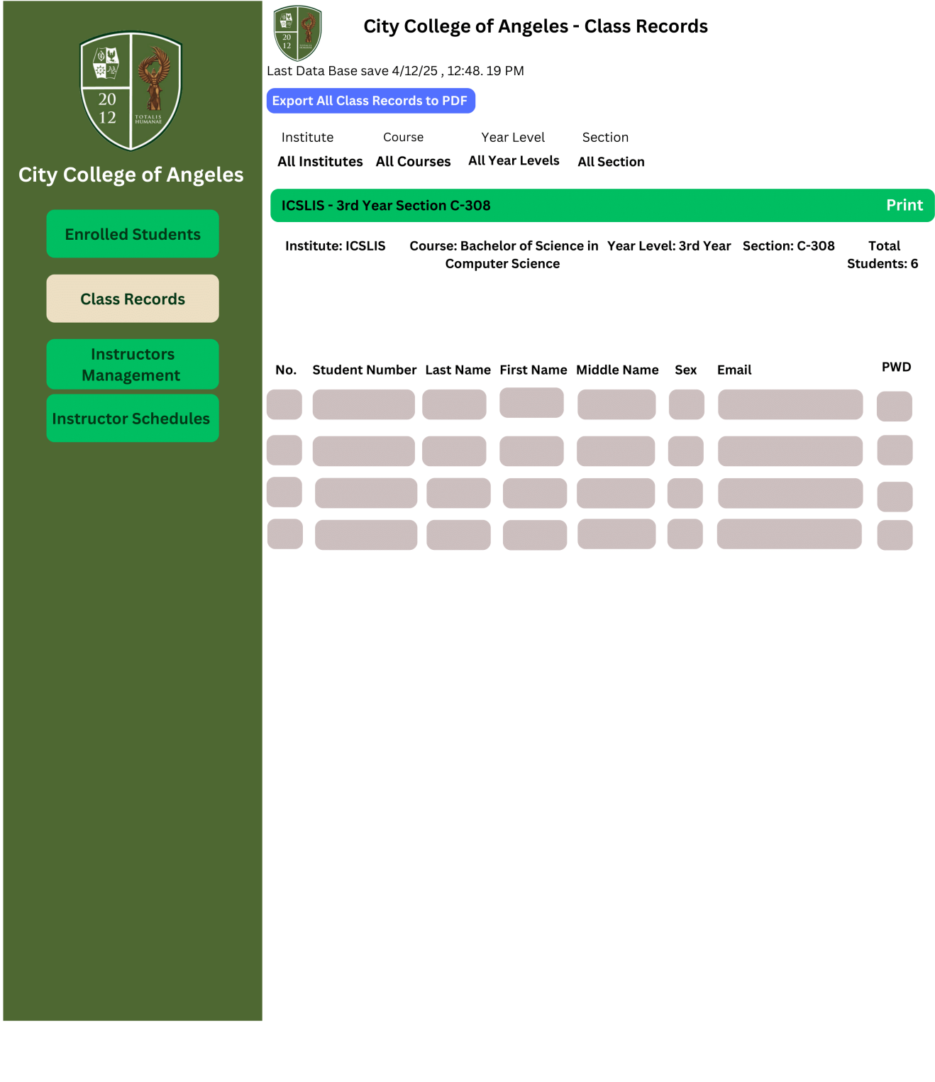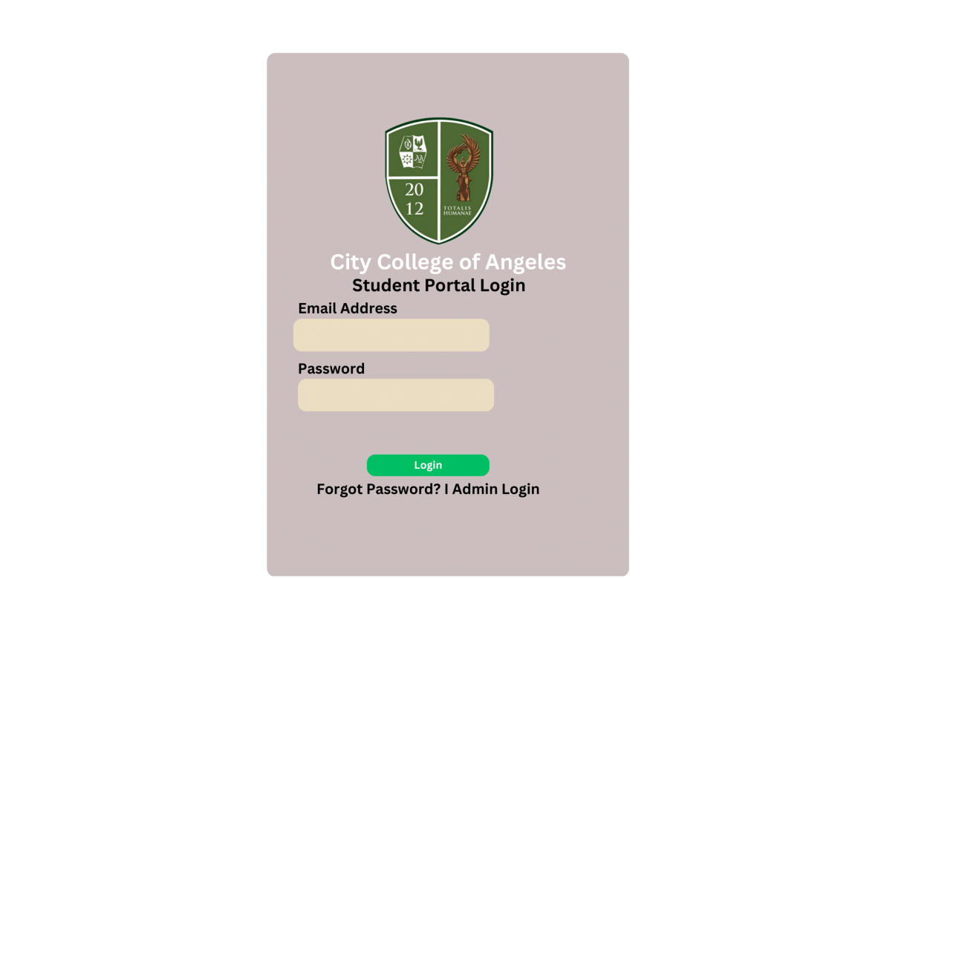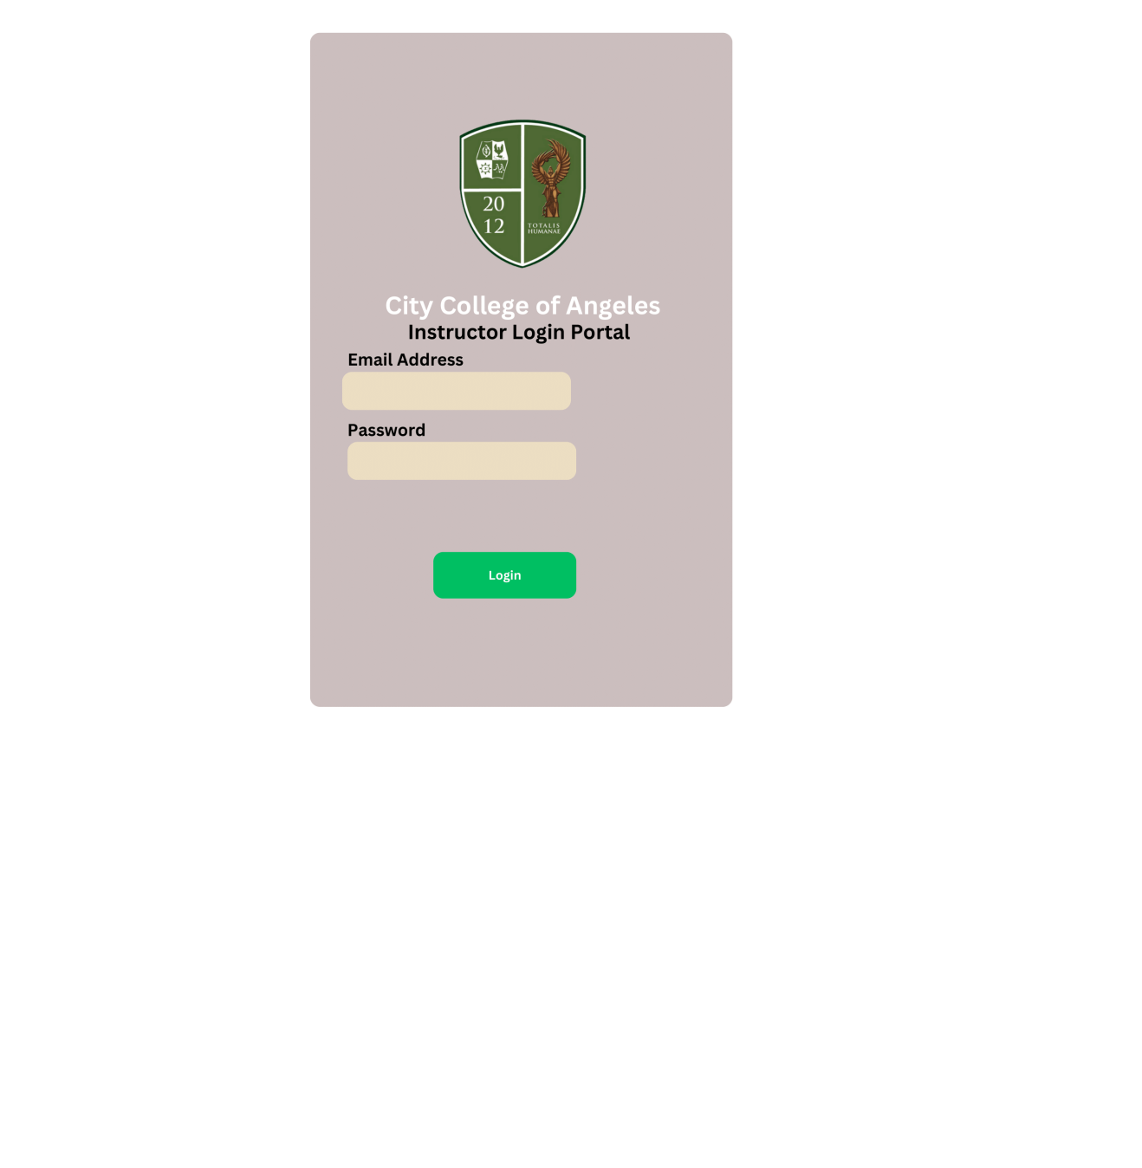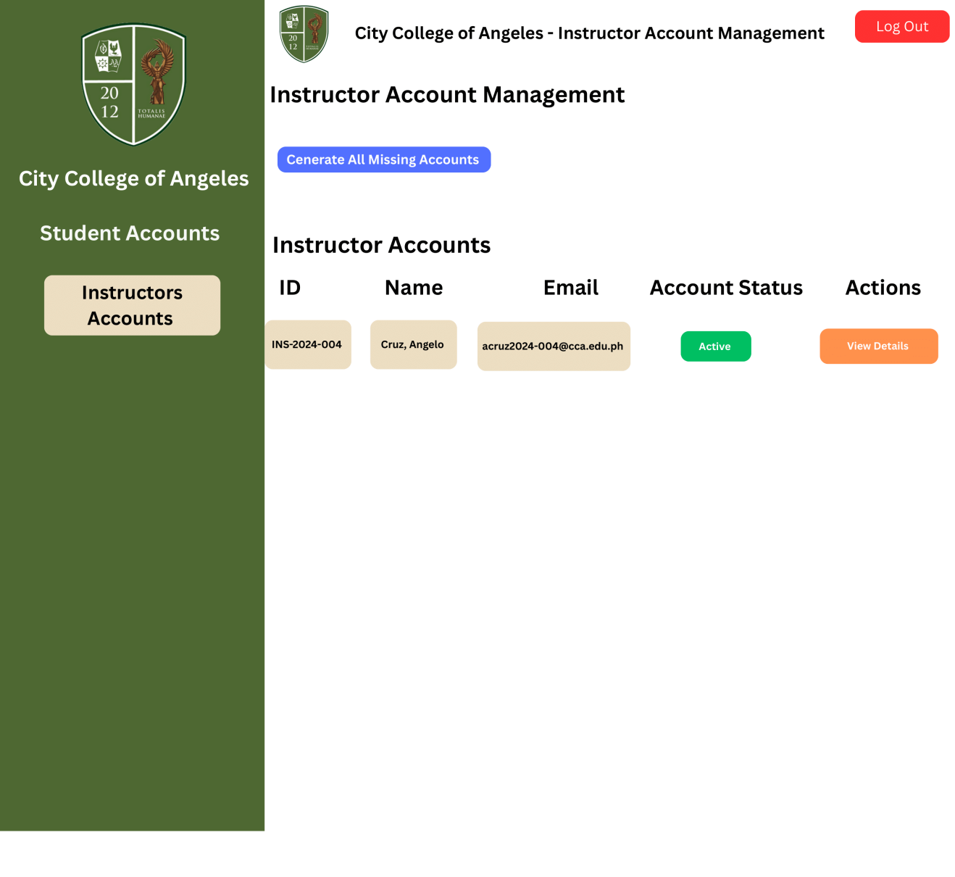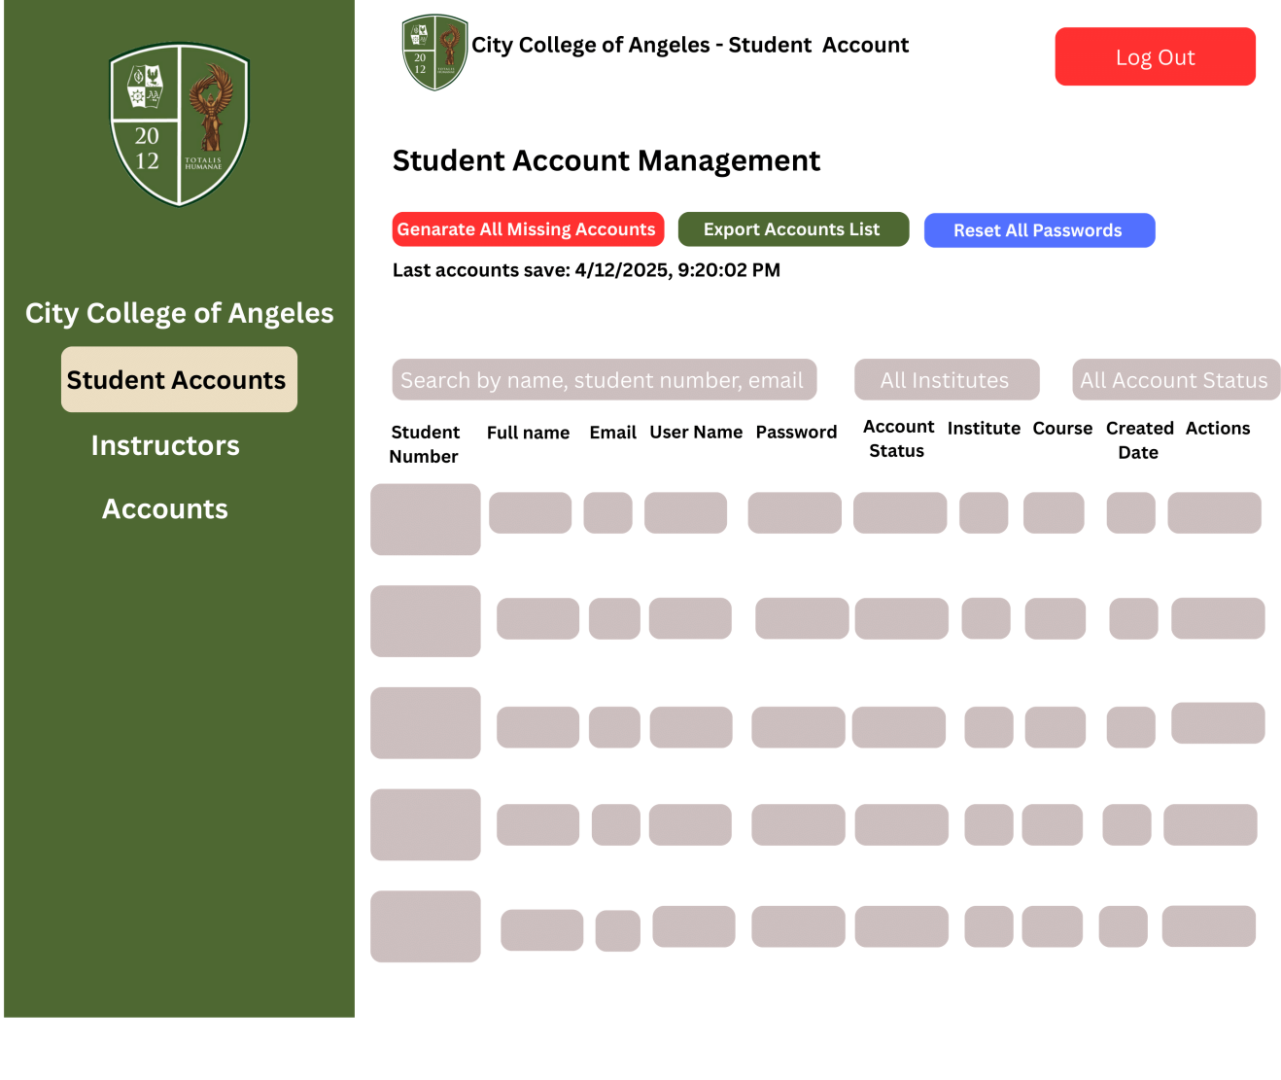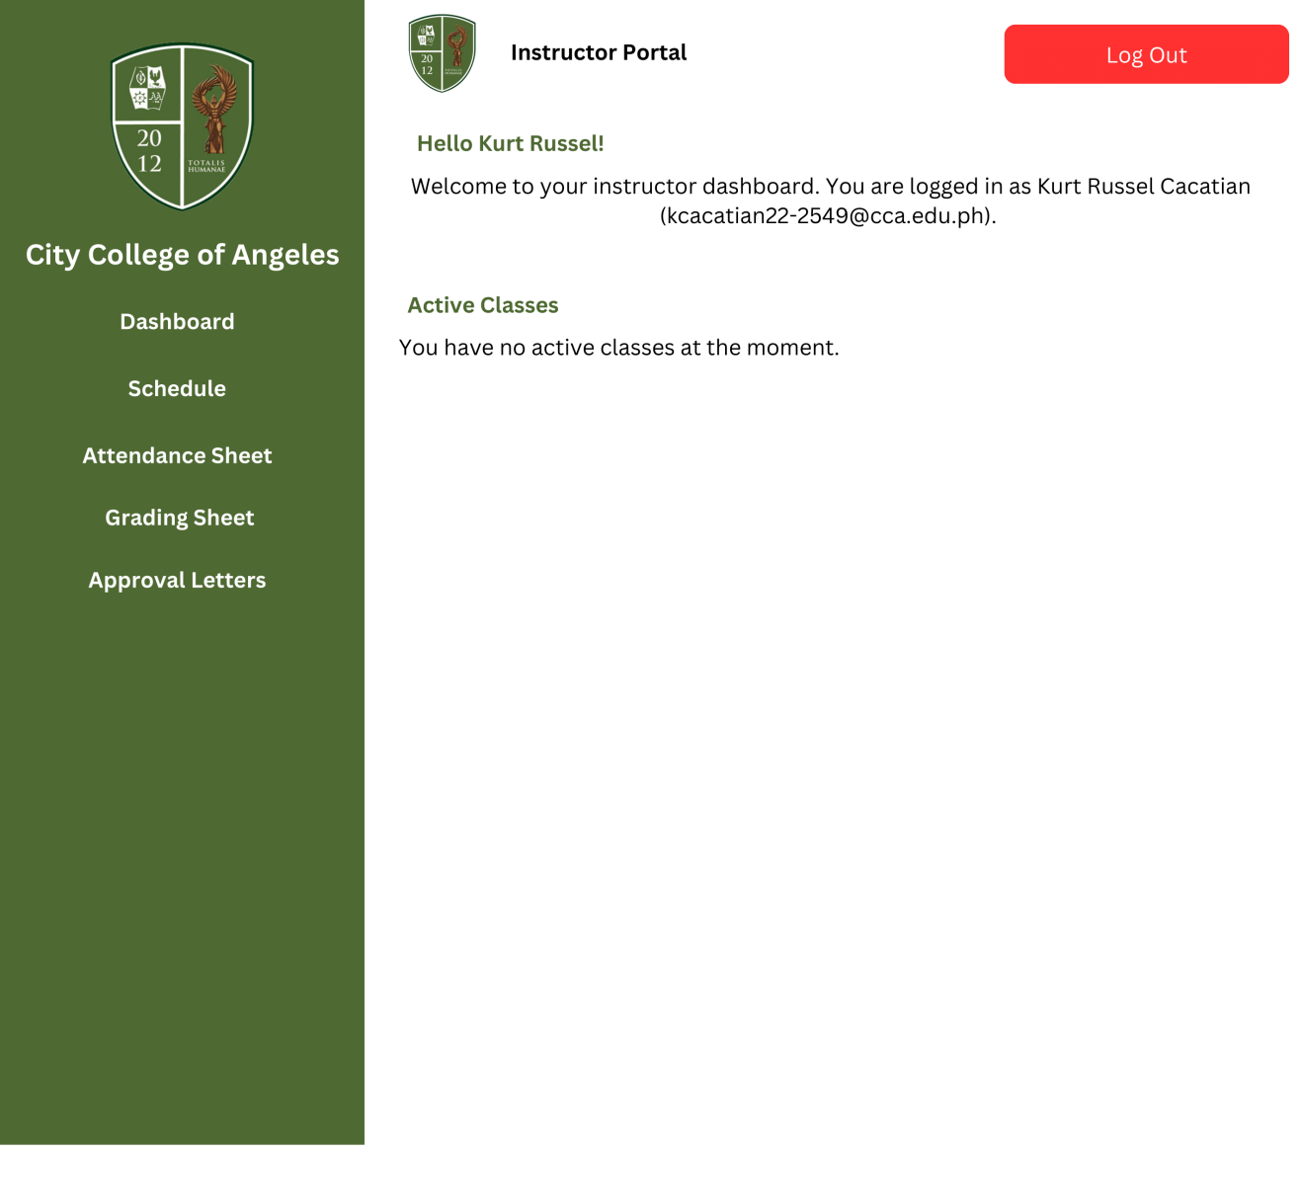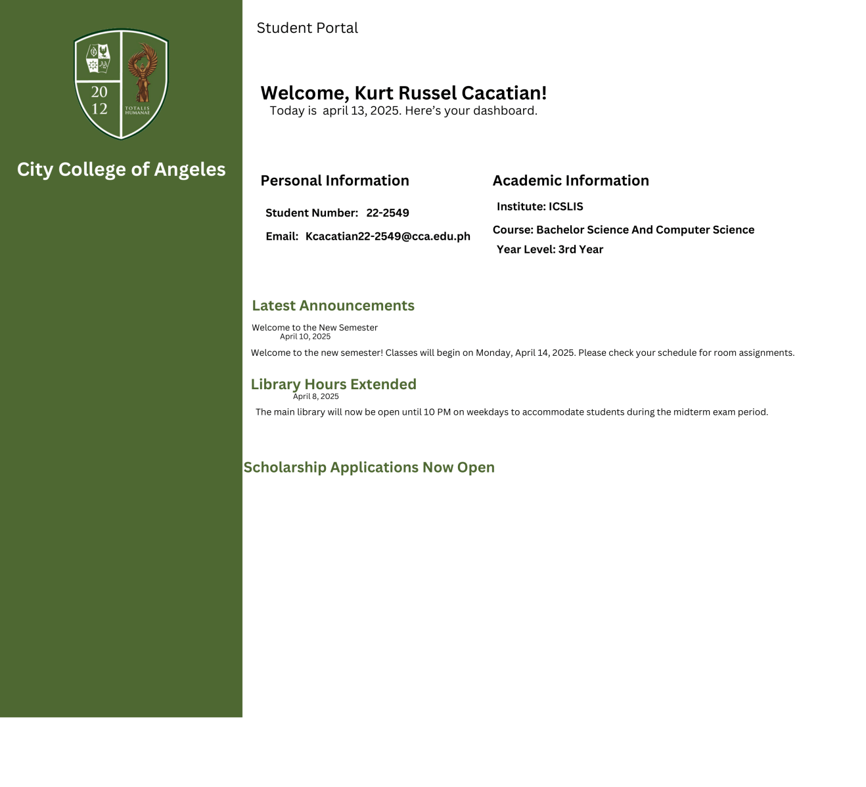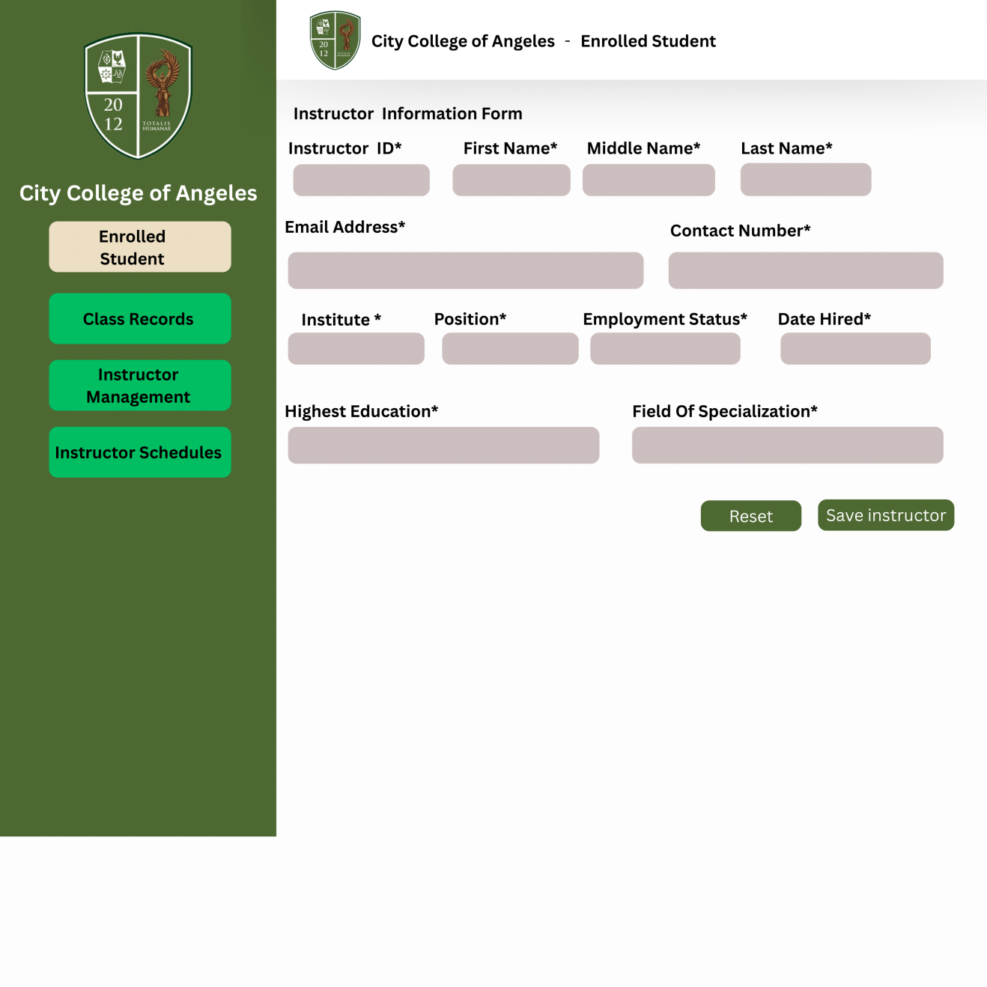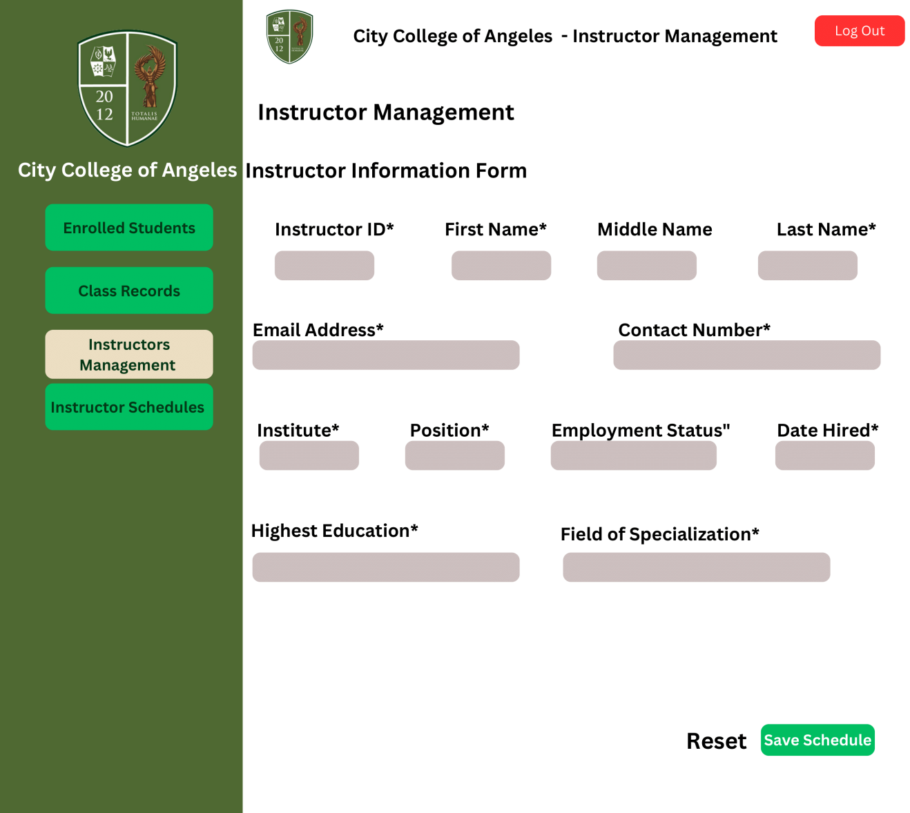
Logical Specifications - diagrams
This section shows the different diagrams that were used in the creation of the CCA Portal Integrated Class Record Management System: Simplifying Academic Data and Performance Tracking. These diagrams simplify academic reporting, student performance monitoring, and class management by showing how data flows between various system components and how users interact with the information handling system.

The web-based system is designed to provide an easy and helpful experience for the instructor, student, dean, coordinator, registrar, and admin. The users have different roles

in the system. The instructor is the one that is responsible for managing class records, by importing class schedule, tracking attendance and the system will easily notify students about their grades and absences, instructor also process the excuse letter of the students, it is either they are going to approve it or sending it to the Dean and Coordinator for further consideration. Instructors can also import scores or manually input them, they can also monitor the history changes, compute grades, generate a summary of student performance, and identify the top 10 best students and those students who need some interventions. They consolidate reports for students with academic problems, and take notes for the interventions made.

Hardware Specification
Table 1. Desktop specifications used in development and testing
Specification | Minimum | Recommended
Operating System | Windows 11 | Windows 11
Processor | 11th Gen Intel(R) Core(TM) 15-113567 @ 2.40GHz 2.42 GHz
RAM | 16.0 GB (158 GB usable)
Hard drive | 512GB | 512GB
Monitor | 15.6-Inch Huawei Fullview Display | 15.6-Inch Huawei Fullview Display
Video Card | 8GB | 16GB

Table 2. Desktop specifications used in implementation
Specification | Minimum | Recommended
Operating System | Windows 11 | Windows 11
Processor | 11th Gen Intel(R) Core(TM) 15-113567 @ 2.40GHz 2.42 GHz
RAM | 16.0 GB (158 GB usable)
Hard drive | 512GB | 512GB
Monitor | 15.6-Inch Huawei Fullview Display | 15.6-Inch Huawei Fullview Display
Video Card | 8GB | 16GB

Data Flow Diagram (Context Level 0)

The Context Level (Level 0) Data Flow Diagram (DFD) of the system outlines the primary entities and their interactions, It begins with five entities: Admin, Registrar, Dean, Instructor, and Student. Users use the system to perform a particular task. Instructors use the system to keep track of student attendance, academic reports, and class records. Students can view their attendance, submit excuse letters, check their academic performance/standing, and receive automated warnings when they are set to become FA or they have a failing grade. The Registrar can change the student's enrolment status to Enrolled, UW, LOA, or OD. The dean and coordinators examine high-level excuse requests and summaries of academic deliberations. They can also view the list of officially dropped students. Admin is the one who can manage the user's role (ex., Instructor, Student, Dean, and Registrar), they can configure the system, and ensure accurate system setup. To ensure accuracy, consistency, and immediate access to records, a single database manages all communications and data entry.

Data Flow Diagram (Level 1)

The Level 1 Data Flow Diagram (DFD) allows a more comprehensive understanding of the Level 0 diagram's processes, providing a deeper comprehension of the system's functionalities. Instructors can view the subjects they are teaching and manage their class records. Keeping track of attendance so that every student can see and be aware of their absences. They can also import raw scores, which will be reflected in the student's portal, helping students to become more aware if they have a failing grade. The date will immediately appear on the screen as soon as the score is submitted. At the bottom portion (the entrance date, which the instructor can change if he or she wishes to record the activity's date. The faculty can evaluate a student's excuse letter and determine whether to approve it right away or send it to the dean or coordinator for further consideration. The portal shows the students who passed, failed, got FA, UW, or LOA, and other conditions in the computing of grades. At the end of the semester, instructors can identify students who need more academic assistance. The Registrar can manage the summary report of enrolled students. Students' excuse letters are reviewed and approved by the program coordinator or dean. They have access to view the list of students who have been officially dropped and also the summaries of the deliberations for academic interventions. All of the data produced by the system is transmitted to the admin entity, which is controlled and accessible through the admin page.

Use Case Diagram

The Use Case Diagram illustrates the functions and interactions between the users (admin, registrar, dean, instructor, and students) and the
system. Teachers can create and manage class records, enter raw scores, keep track of attendance, approve excuse letters, and produce reports that include the top ten students in each class. Students can see their grades, keep track of their attendance, and get notifications automatically when they are going to fail or have many absences in their individual class records. Students can upload excuse letters if they are marked absent. Teachers are the first ones who need to approve the letter, and the dean and coordinator will review if the student is marked as FA. With access to the master list of enrolled students, registrars can change a student's status as necessary(Enrolled, UW, LOA, or OD). While the student will still be listed in the class list, their enrolment status will change to inactive after their name has been updated. The coordinator or dean may accomplish specific duties like examining dropped students, approving excuse letters, and monitoring student progress through discussion summaries. The admin can easily create a new schedule, secure data, and ensure all the features are working to avoid delays.

Flowchart
The students' role in the portal is to view their class schedules, attendance records, and their scores and grades, They clearly see the progress of their academic performance if they are doing well or not. They receive a warning for their absences, and the portal has an option to upload the excuse letter or other documents, which will be reviewed by the instructor or higher authorities. It also keeps student updated on their enrollment status. The portal allows students to view the summaries of their performance.
The dean and the coordinator's role is to view the lists of officially dropped students and approve the excuse letters from the students due to absences. They have access to manage the deliberation summaries, which consolidate reports on students with academic or attendance problems and the interventions applied. Their approval is required for excusing absences. They make sure that academic policies, rules, and standards are implemented across the system.
The registrar's role is to manage the master list of enrolled students, and they are the ones who will update the student's enrollment status to Unofficial Withdrawal (UW), Leave of Absence (LOA), or Officially Dropped (OD). When the status has changed, the registrar can add remarks, and the date will be updated. The students' names remain visible, but they will be deactivated in the class records. The registrar also generates the summary reports of enrolled students, and they make sure that all the records are accurate and always updated. This procedure helps to maintain the reliability and consistency of enrollment data throughout the semester.
The admin has an overview of the entire system, account management, handling users' registrations, and approving enrolment requests. They have authority for the payment balances, update the class schedules, secure the user's privacy, and maintain a database to ensure real-time data accuracy. The admins have the highest level of role in the system. Their responsibility is very important and crucial in keeping the system secure, efficient for the user, and aligned with the school policies

Software Specifications
Functionality:
The software should allow students to view past and present course schedules, helping them track their academic performance. It shall also allow students to view and upload documents such as excuse letters, activities, and more. Students must have real-time communication with instructors, coordinators, and deans. The software must

facilitate seamless management for instructors, such as tracking student attendance, computing grades, and providing academic tasks. The software shall enable the registrar and administrator to control the entire system, as they are responsible for managing user access, configuring system settings, and ensuring the smooth operation, security, and integrity of the portal. The software should allow deans to provide high-level academic oversight and access decision-making tools.

External Interfaces:
The software will have a user-friendly, web-based interface accessible on desktops, laptops, tablets, and mobile devices. Users such as students, instructors, coordinators, deans, registrars, and administrators will have role-based access to specific features. Real-time messaging and notifications will support communication between students and school officials. The system will work on standard internet-connected devices and support printers and scanners for handling physical documents like grade reports and excuse letters. Users can upload files in formats such as PDF, DOCX, JPEG, and PNG. Real-time chat and alerts, either through email or in-system, will keep users informed about grades, tasks, and messages.
Performance:
The software is built to run smoothly and respond quickly across all devices. Common actions like checking schedules, uploading files, or sending messages should load within 1 to 5 seconds under normal conditions. Real-time chat and notifications are

designed to work with minimal delay. The system will be available at all times, with maintenance done during off-hours.
Design constraints imposed on an implementation:

RESULTS
System/Application Outputs
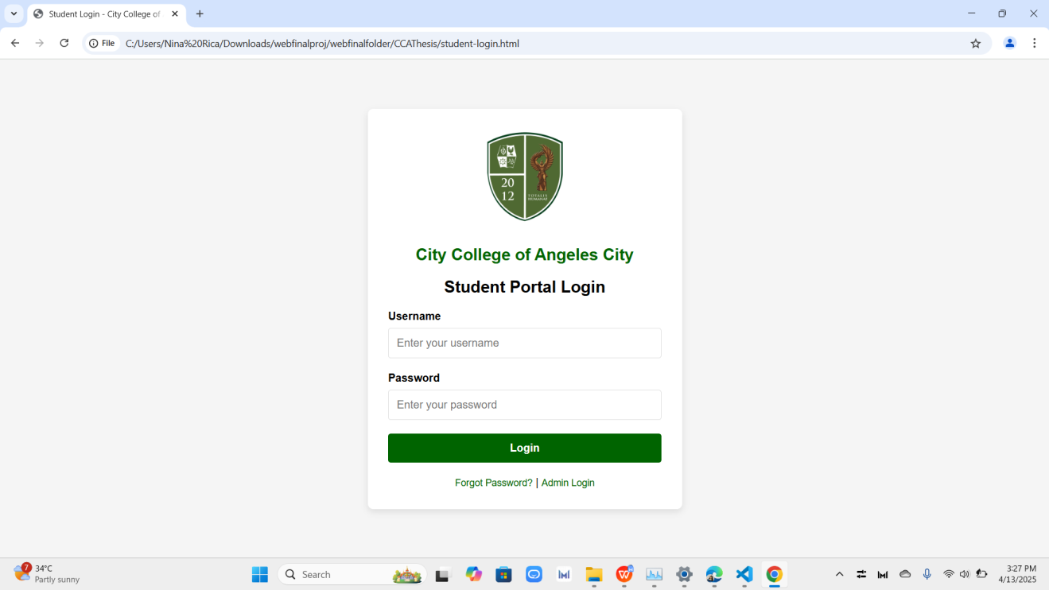
Figure 1. Startup Screen Output for Student

In the figure above, the Student Login provides students with a personalized and secure access point to the academic system. By entering their designated credentials, students can access essential academic information such as their class schedules, course enrollments, and personal records.

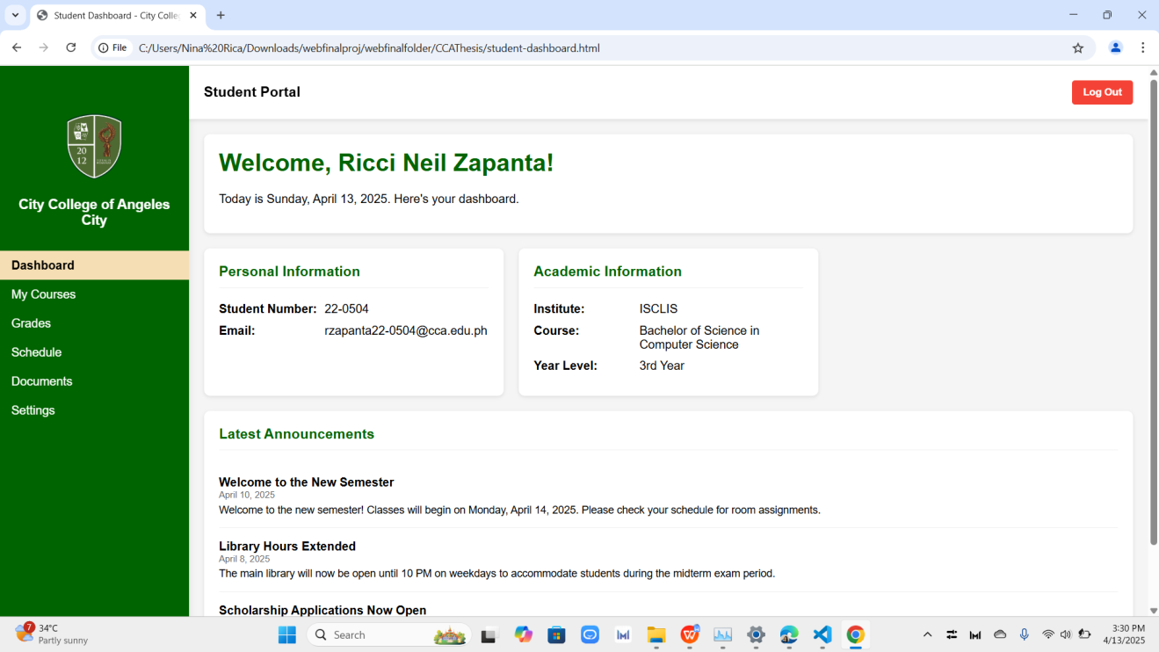
Figure 2. Student Dashboard

In the figure above, the student dashboard provides quick access to personal and academic details, including student ID, email, course, and year level. It also displays important announcements to keep students updated on institutional activities.

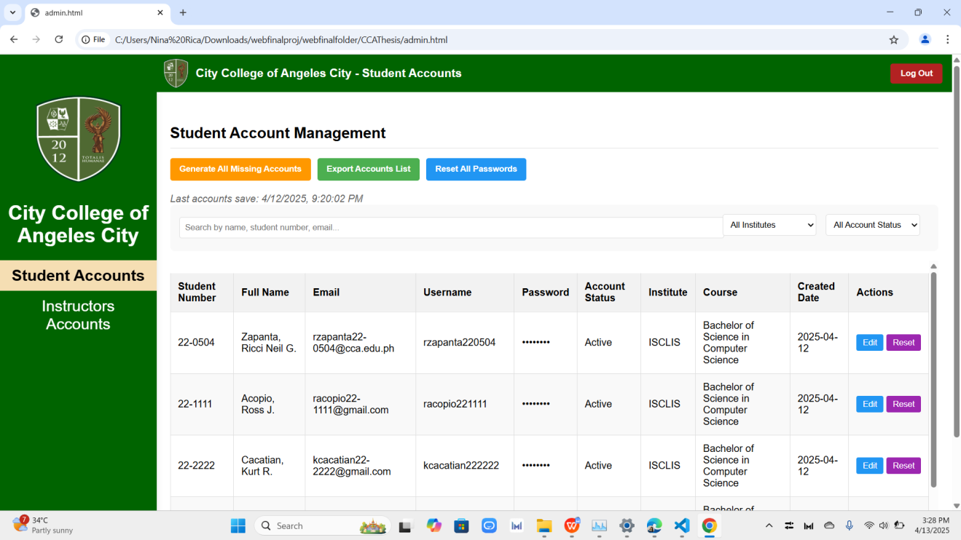
Figure 3. Student Account Management

In the figure above, this admin interface lists all student accounts with key details such as student number, email, username, and course. It allows account creation, password resets, and data updates, ensuring efficient management of student records.

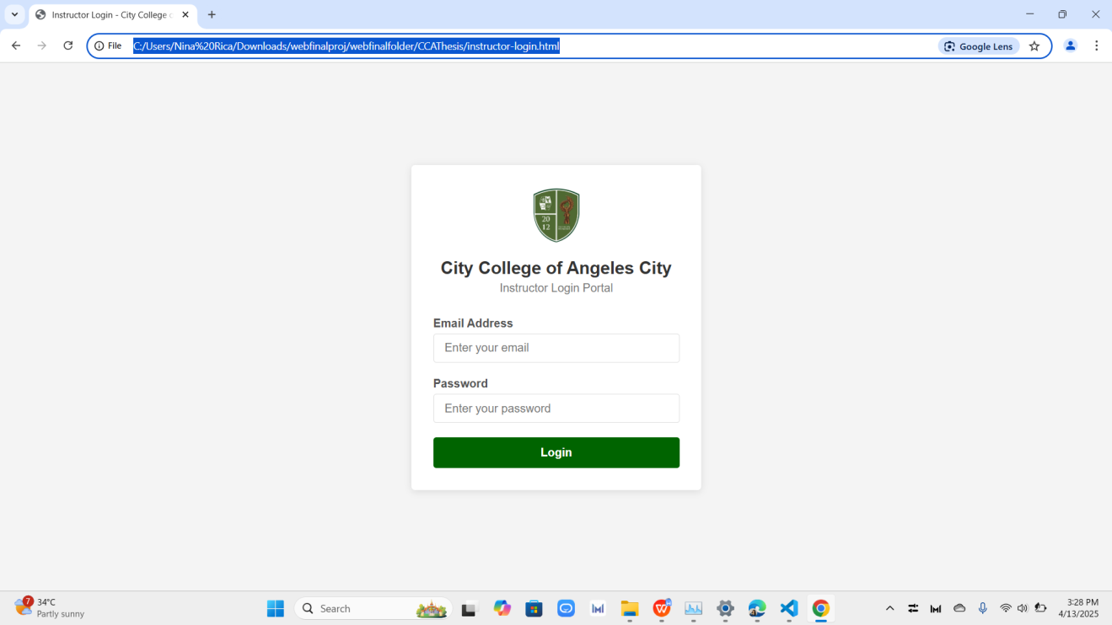
Figure 4. Startup Screen Output for Instructor
The Instructor Login interface provides faculty with secure access to their teaching schedules and class information. It allows instructors to manage academic records relevant to their responsibilities. This feature ensures data privacy and supports accurate, role-based system access.

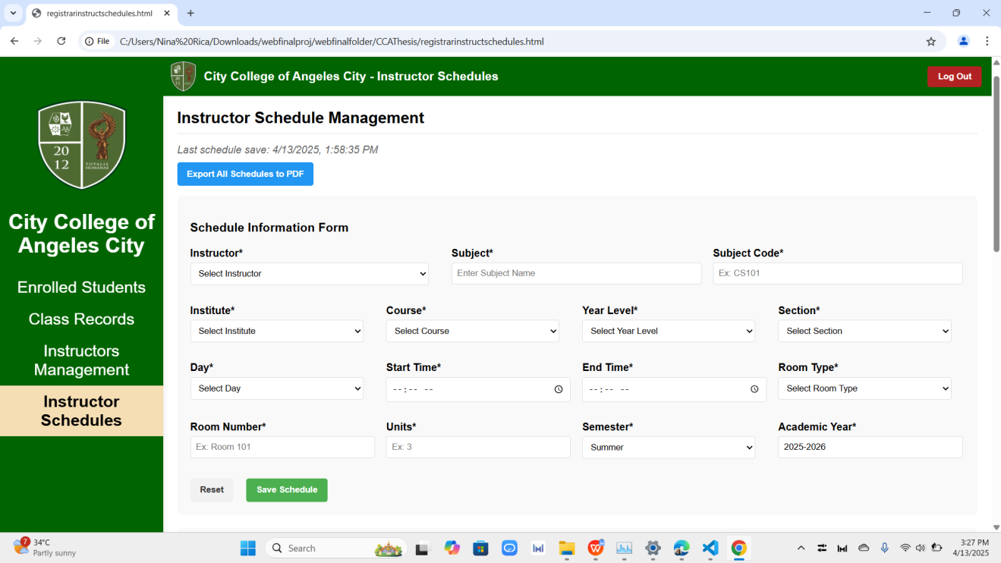
Figure 5. Instructor Schedule Management
In the figure above, Instructor Schedules page is designed to streamline the assignment of teaching loads within the institution. It enables the registrar to input key scheduling details such as subject information, instructor name, time slots, course, room assignments, and semester coverage. The system also features a save function and a PDF export option to facilitate documentation and scheduling accuracy.

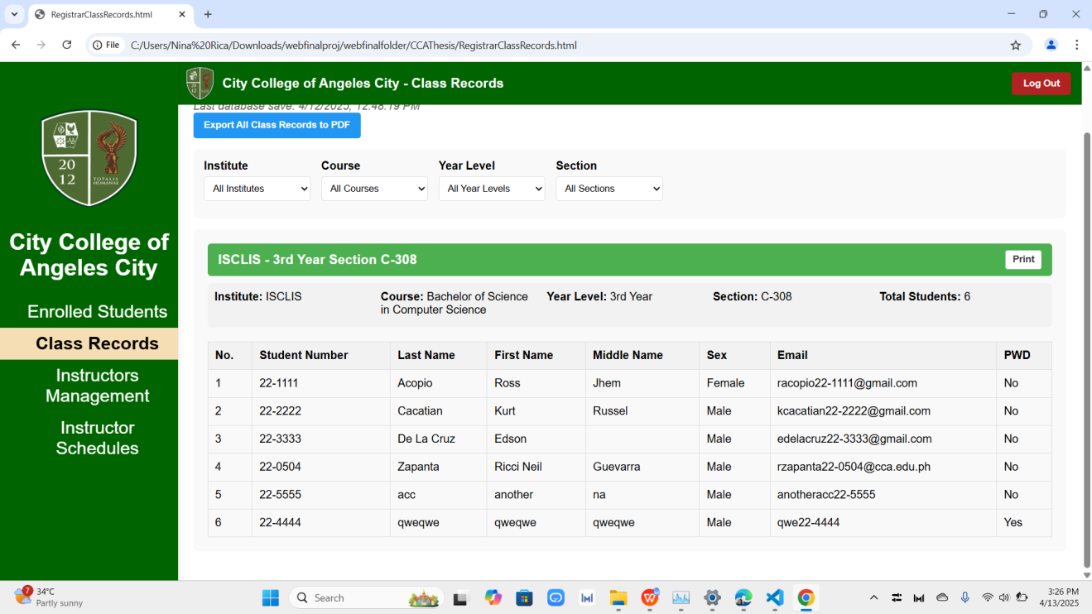
Figure 6. Instructor Class Records
The Class Records module provides an organized view of enrolled students categorized by course, year level, and section. It displays detailed student information such as student numbers, names, sex, email addresses, and disability status. This interface supports academic monitoring and allows data to be exported for reporting and archival purposes.

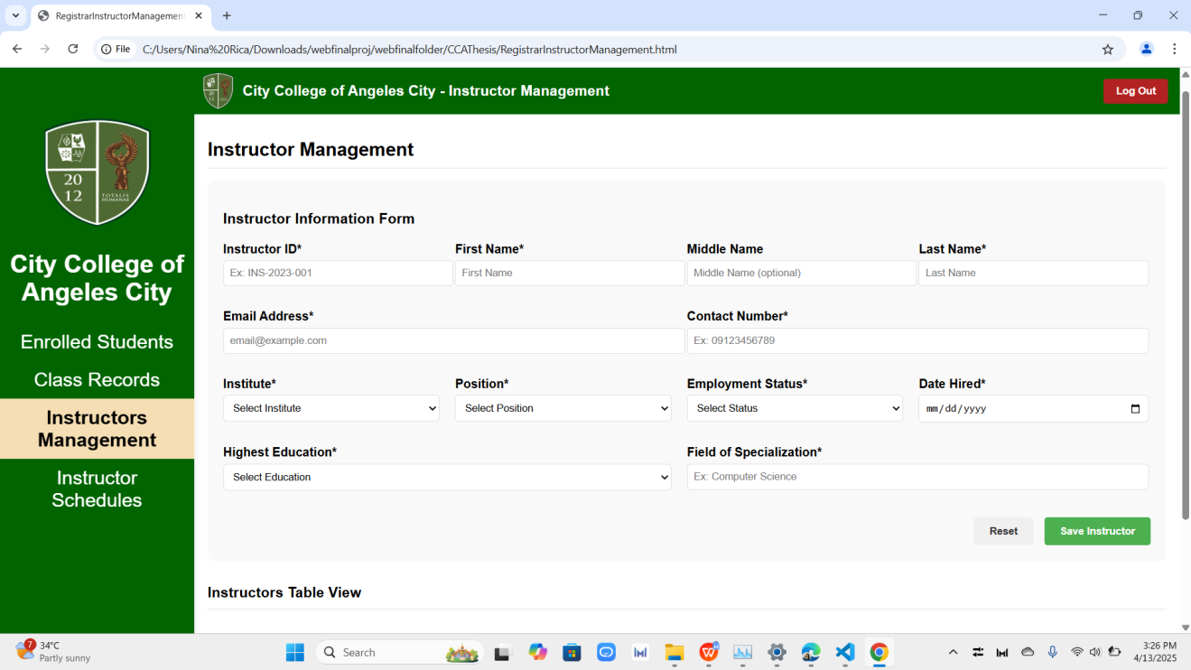
Figure 7. Instructor Management

This section of the system focuses on maintaining comprehensive instructor records. It allows the user to input personal and professional data, including contact details, academic qualifications, employment status, and field of specialization. The form ensures that each instructor’s profile is complete and up-to-date, supporting administrative oversight and HR coordination.

Evaluation Results
Table 7. Evaluation Results of I.T. Experts
Criteria | Mean | Descriptive Rating
Functional Suitability
Performance Efficiency
Compatibility
Usability
Reliability
Security
Maintainability
Portability
Overall Mean

Table 8: Evaluation Results of Non-I.T. Experts
Criteria | Mean | Descriptive Rating
Functional Suitability
Performance Efficiency
Usability
Reliability
Overall Mean

DISCUSSION
Summary of Findings
Conclusions
Recommendations

REFERENCES
Academia. (2023). Management information system of public secondary schools in Sagbayan District: A proposed implementation. Academia.edu. https://www.academia.edu/106255391
Adamson University. (2022). Integrated educational management tool for Adamson University. arXiv. https://arxiv.org/abs/2212.08039
Brown, T., & Patel, S. (2021). Strategies for effective academic data management in modern learning environments. International Journal of Educational Technology, 38(4), 132-148. https://doi.org/10.1016/JET.2021.0102312
Domingo, W. G., Lardizabal, E. N., & Toledo, S. M. V. (2021). Acceptability of K12 senior high school students academic performance monitoring system for private institutions with decision support system. International Journal on Integrating Technology in Education, 10(4), 27–38. https://doi.org/10.5121/ijite.2021.10403
Falebita, O. S. (2022). Secure web-based student information management system. arXiv preprint arXiv:2211.00072. https://doi.org/10.48550/arXiv.2211.00072
Gonzalez, R., & Martinez, L. (2023). Digital transformation in academic record management: A case study of higher education institutions. International Journal of Educational Technology, 45(3), 78–94. https://doi.org/10.1016/IJET.2023.112345
Harris, G., & Roberts, M. (2022). Performance tracking in K-12 education: A technological and pedagogical review. Educational Performance Review, 31(2), 89-103. https://doi.org/10.1109/EPR.2022.0164539
Lee, S., & Chan, K. (2022). The integration of online academic portals in higher education: Opportunities and challenges. Journal of Online Learning and Technology, 18(1), 12-28. https://doi.org/10.1109/JOLT.2022.0301946
Libadia, M., Botangen, K. A., Lucero, P. J., & Tecson, J. (2025). Development of a web-based records management system: An ERMS initiative for the Office of Senior Citizen Affairs in the Philippines. Records Management Journal. https://doi.org/10.1108/RMJ-06-2023-0031
Manikan, J., & Purificacion, M. (2022). File management and monitoring system of Kasambuhay Estigmatine Foundation Inc. Journal of Information Systems, 8(2), 15–25. https://doi.org/10.20944/preprints202208.0157.v1
Mariano Marcos State University. (2024). MMSU holds training-workshop on new record management system app. MMSU. https://www.mmsu.edu.ph/news/mmsu-holds-training-workshop-on-new-record-management-system-app
Morris, D., & Chang, P. (2023). Educational technologies in tracking student academic performance: A systematic review. International Journal of Educational Technology & Society, 28(2), 103-119. https://doi.org/10.1109/ITSS.2023.0174568
Nguyen, P., & Tran, A. (2021). Enhancing student information systems for real-time academic performance tracking. Journal of Educational Informatics, 23(3), 44-58. https://doi.org/10.1109/JEI.2021.0348952
Nicolas, P. M. O. (2024). AcadTrack: Development and assessment of learner’s academic performance tracking system with decision support. The QUEST: Nueva Ecija University of Science and Technology, Graduate School, 3(1), 1–10. https://doi.org/10.60008/thequest.v3i1.86
Philippine Information Agency. (2024). TESDA Soccsksargen launches records management information system. PIA. https://pia.gov.ph/tesda-soccsksargen-launches-records-management-information-system
Pinero, M. (2023). Design and implementation of Baggao North Central School computer-based record management system. International Journal for Multidisciplinary Research, 5(2), 1–13. https://doi.org/10.1016/j.ijfmr.2023.03.001
ResearchGate. (2023). Design and implementation of Baggao North Central School computer-based record management system. ResearchGate. https://www.researchgate.net/publication/369370914
Romblon, A. M. P. (2023). Exploring academic operations: A focus on the implementation of Class Record Optimization and Automation System (CROAS). International Journal of Sciences: Basic and Applied Research, 68(1), 45–58. https://doi.org/10.12345/ijsbar.v68i1.16695
Smith, J., & Johnson, R. (2023). Class record management systems in higher education: Current trends and future directions. Journal of Educational Systems, 44(2), 55-71. https://doi.org/10.1109/JES.2023.0256
Tanguilig, B. T., & King, B. (2023). e-DoX: DEPED student grade records management system with implementation of advanced encryption standard and PKI infrastructure. International Journal of Advanced Research in Computer Science, 14(2), 45–56. https://doi.org/10.26483/ijarcs.v14i2.1252
Technical Education and Skills Development Authority (TESDA) Region 12. (2024, November 15). TESDA Soccsksargen launches records management information system. Philippine Information Agency. https://pia.gov.ph/news/articles/1056789
Thilakavalli, K., Saraswathi, A., & Rajagopal, D. (2023). Efficient record management system for higher educational institutions using TOE and UTAUT model. International Journal on Recent and Innovation Trends in Computing and Communication, 11(11), 149–155. https://doi.org/10.17762/ijritcc.v11i11.9118
Williams, J., & Foster, E. (2021). Integrating learning management systems with student performance tracking: A comparative review. Journal of Learning Technology, 40(5), 210-227. https://doi.org/10.1109/JLT.2021.0172328
Bodily, R., & Verbert, K. (2021). Review of research on student-facing learning analytics dashboards and educational recommender systems. IEEE Transactions on Learning Technologies, 10(4), 405–418. https://doi.org/10.1109/TLT.2017.2740172
Jayashanka, R., Hettiarachchi, E., & Hewagamage, K. P. (2022). Technology enhanced learning analytics dashboard in higher education. Electronic Journal of e-Learning, 20(2), 111–123. https://doi.org/10.34190/ejel.20.2.2189
Liao, P., & Chen, C. M. (2023). Integration of artificial intelligence performance prediction and learning analytics to improve student learning in online engineering courses. International Journal of Educational Technology in Higher Education, 20(1), 4. https://doi.org/10.1186/s41239-022-00372-4
Munagandla, V. B., Dandyala, S. S. V., Vadde, B. C., & Dandyala, S. S. M. (2023). Leveraging cloud data integration for enhanced learning analytics in higher education. International Journal of Advanced Engineering Technologies and Innovations, 1(03), 434–450. https://ijaeti.com/index.php/Journal/article/view/631
Hill, E. (2021). The effects of student activity dashboards on student participation, performance, and persistence (Doctoral dissertation). Nova Southeastern University. Retrieved from https://nsuworks.nova.edu/gscis_etd/1026/
Kokoç, M., & Altun, A. (2021). Effects of learner interaction with learning dashboards on academic performance in an e-learning environment. Behaviour & Information Technology, 40(2), 161–175. https://doi.org/10.1080/0144929X.2019.1680731
Delos Santos, M. S. M., Durano, D. C., & Hortillosa, A. D. (2023). The development of a proposed learning management system for senior high schools in the Philippines. International Journal of Information and Education Technology, 13(3), 430–438
Brasileño, I., & Bidad, W. D. (2021). The state of ICT integration in the school learning system in junior high schools, General Santos – Philippines. Sapienza: International Journal of Interdisciplinary Studies, 2(3), 76–88
Duldulao, A. V., & Duldulao, J. R. R. (2021). Online student academic performance monitoring and evaluation system of the Quirino State University. International Journal of Science and Research, 10(5), 1234–1238.

Singh, R., & Sharma, P. (2021). Digital Transformation in Education: Enhancing Efficiency through Automated Systems. International Journal of Educational Technology, 14(3), 45-58.
Garcia, M., Cruz, L., & Tan, R. (2023). The Impact of Automated Record Management on Academic Efficiency. Journal of Educational Research and Innovation, 19(2), 112-130.

APPENDICES
Appendix A:
Appendix B:
Appendix C:
Appendix D:
Appendix E:
Appendix F:
Appendix G:
Appendix H:
Appendix I:

Appendix J:
Appendix K:
Appendix L:
Appendix M:

Appendix I:: Flowchart
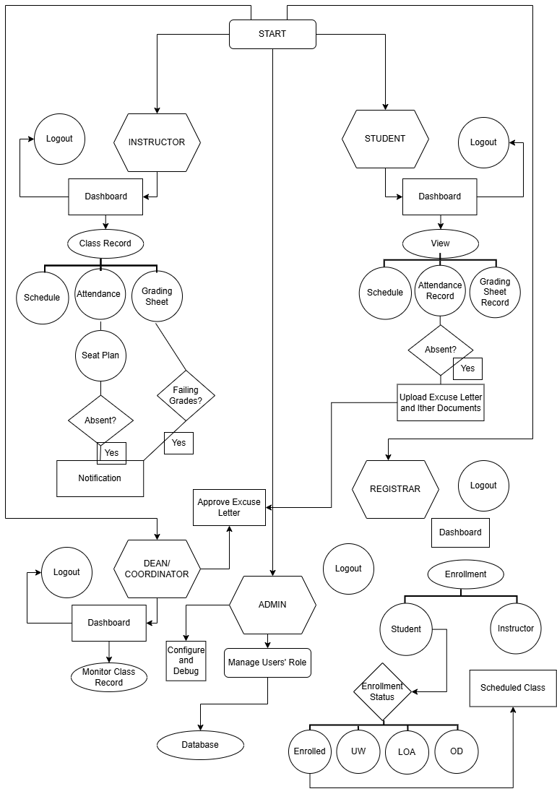
Appendix K: Data Flow Diagram Context Level 0
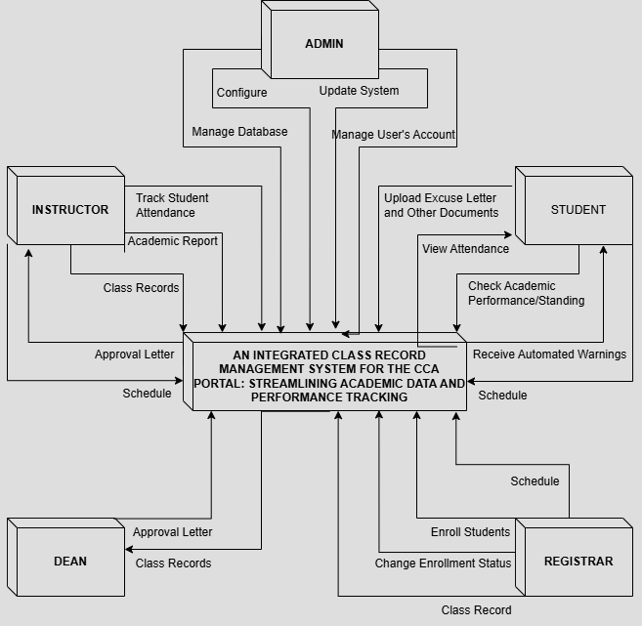
%3CmxGraphModel%3E%3Croot%3E%3CmxCell%20id%3D%220%22%2F%3E%3CmxCell%20id%3D%221%22%20parent%3D%220%22%2F%3E%3CmxCell%20id%3D%222%22%20style%3D%22edgeStyle%3Dnone%3Brounded%3D0%3BorthogonalLoop%3D1%3BjettySize%3Dauto%3Bhtml%3D1%3BexitX%3D0%3BexitY%3D0%3BexitDx%3D10%3BexitDy%3D80%3BexitPerimeter%3D0%3BentryX%3D0.313%3BentryY%3D-0.013%3BentryDx%3D0%3BentryDy%3D0%3BentryPerimeter%3D0%3Belbow%3Dvertical%3B%22%20edge%3D%221%22%20parent%3D%221%22%3E%3CmxGeometry%20relative%3D%221%22%20as%3D%22geometry%22%3E%3CmxPoint%20x%3D%22380%22%20y%3D%22191.04%22%20as%3D%22sourcePoint%22%2F%3E%3CmxPoint%20x%3D%22380.77%22%20y%3D%22450.00000000000006%22%20as%3D%22targetPoint%22%2F%3E%3C%2FmxGeometry%3E%3C%2FmxCell%3E%3C%2Froot%3E%3C%2FmxGraphModel%3E%3CmxGraphModel%3E%3Croot%3E%3CmxCell%20id%3D%220%22%2F%3E%3CmxCell%20id%3D%221%22%20parent%3D%220%22%2F%3E%3CmxCell%20id%3D%222%22%20style%3D%22edgeStyle%3Dnone%3Brounded%3D0%3BorthogonalLoop%3D1%3BjettySize%3Dauto%3Bhtml%3D1%3BexitX%3D0%3BexitY%3D0%3BexitDx%3D10%3BexitDy%3D80%3BexitPerimeter%3D0%3BentryX%3D0.313%3BentryY%3D-0.013%3BentryDx%3D0%3BentryDy%3D0%3BentryPerimeter%3D0%3Belbow%3Dvertical%3B%22%20edge%3D%221%22%20parent%3D%221%22%3E%3CmxGeometry%20relative%3D%221%22%20as%3D%22geometry%22%3E%3CmxPoint%20x%3D%22380%22%20y%3D%22191.04%22%20as%3D%22sourcePoint%22%2F%3E%3CmxPoint%20x%3D%22380.77%22%20y%3D%22450.00000000000006%22%20as%3D%22targetPoint%22%2F%3E%3C%2FmxGeometry%3E%3C%2FmxCell%3E%3C%2Froot%3E%3C%2FmxGraphModel%3E

Appendix L: Data Flow Diagram Level 1(Instructor)
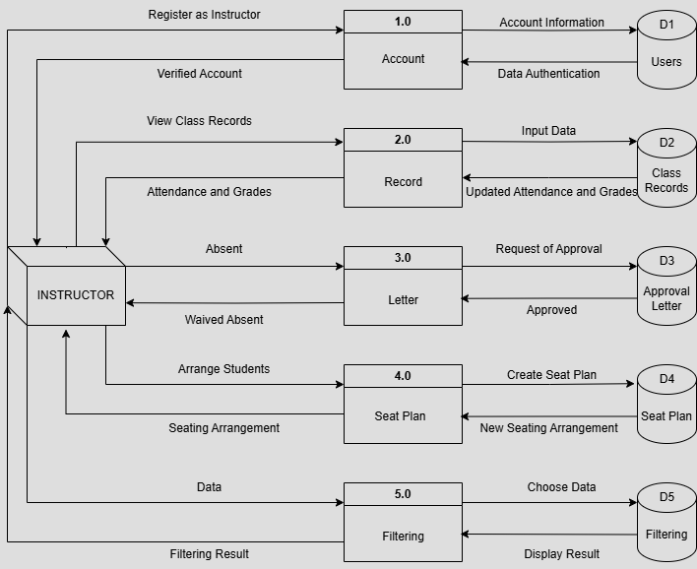
Data Flow Diagram Level 1(Student)
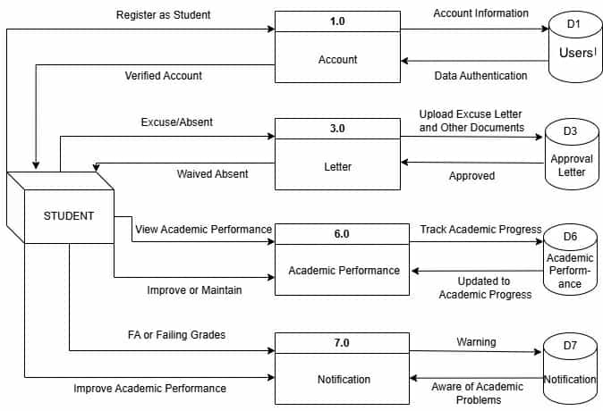

Data Flow Diagram Level 1(Dean/Coordinator)
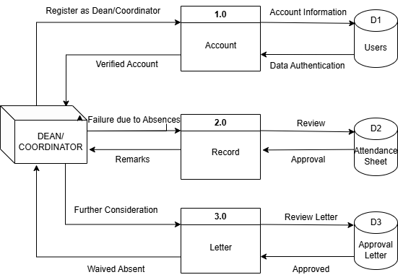
Data Flow Diagram Level 1(Registrar)
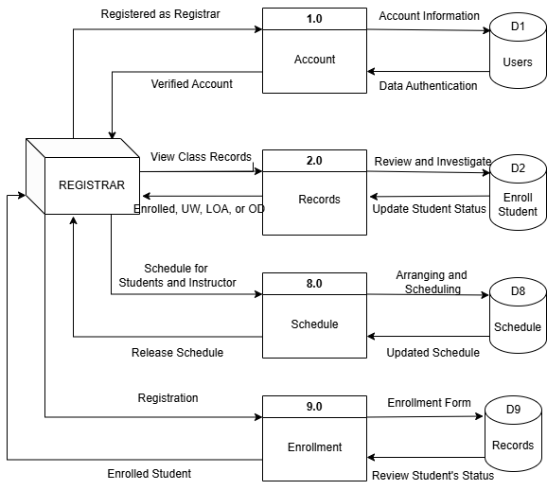

Data Flow Diagram Level 1(Admin)
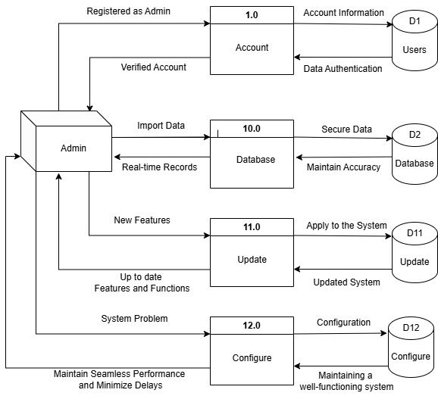

Appendix M: Use Case Diagram
Use Case Diagram (Instructor)
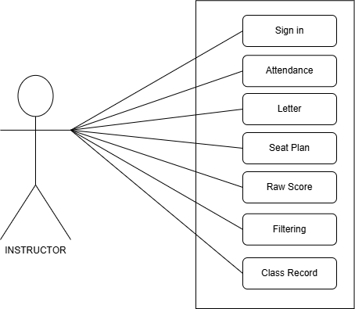
Use Case Diagram (Student)
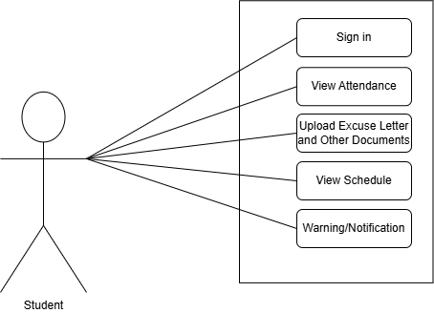

Use Case Diagram (Dean/Coordinator)
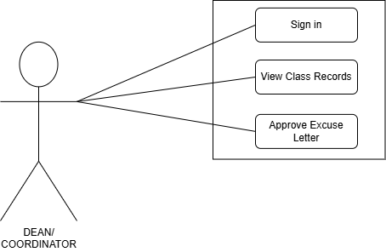
Use Case Diagram (Registrar)
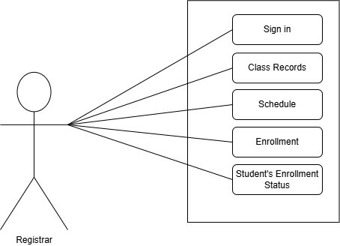

Use Case Diagram (Admin)
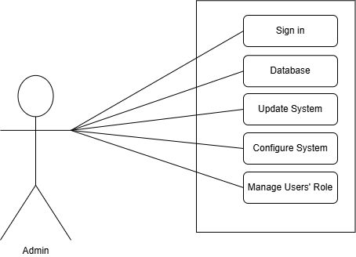

Appendix N: Resume
